**Calibration using known source in**

**VSPEC (Visual Spec) Software 28/7/2024:**

***Andrew Thornett www.astronomy.me.uk***

***References:***

VSPEC – Download software

<http://www.astrosurf.com/vdesnoux/download.html>

VSPEC – Tutorials on using software

<http://www.astrosurf.com/vdesnoux/tutorial.html>

VSPEC - Calibration process

<http://www.astrosurf.com/vdesnoux/howto02.html>

***How to undertake calibration (my own screenshots):***

Load the calibration spectrum into VPSEC

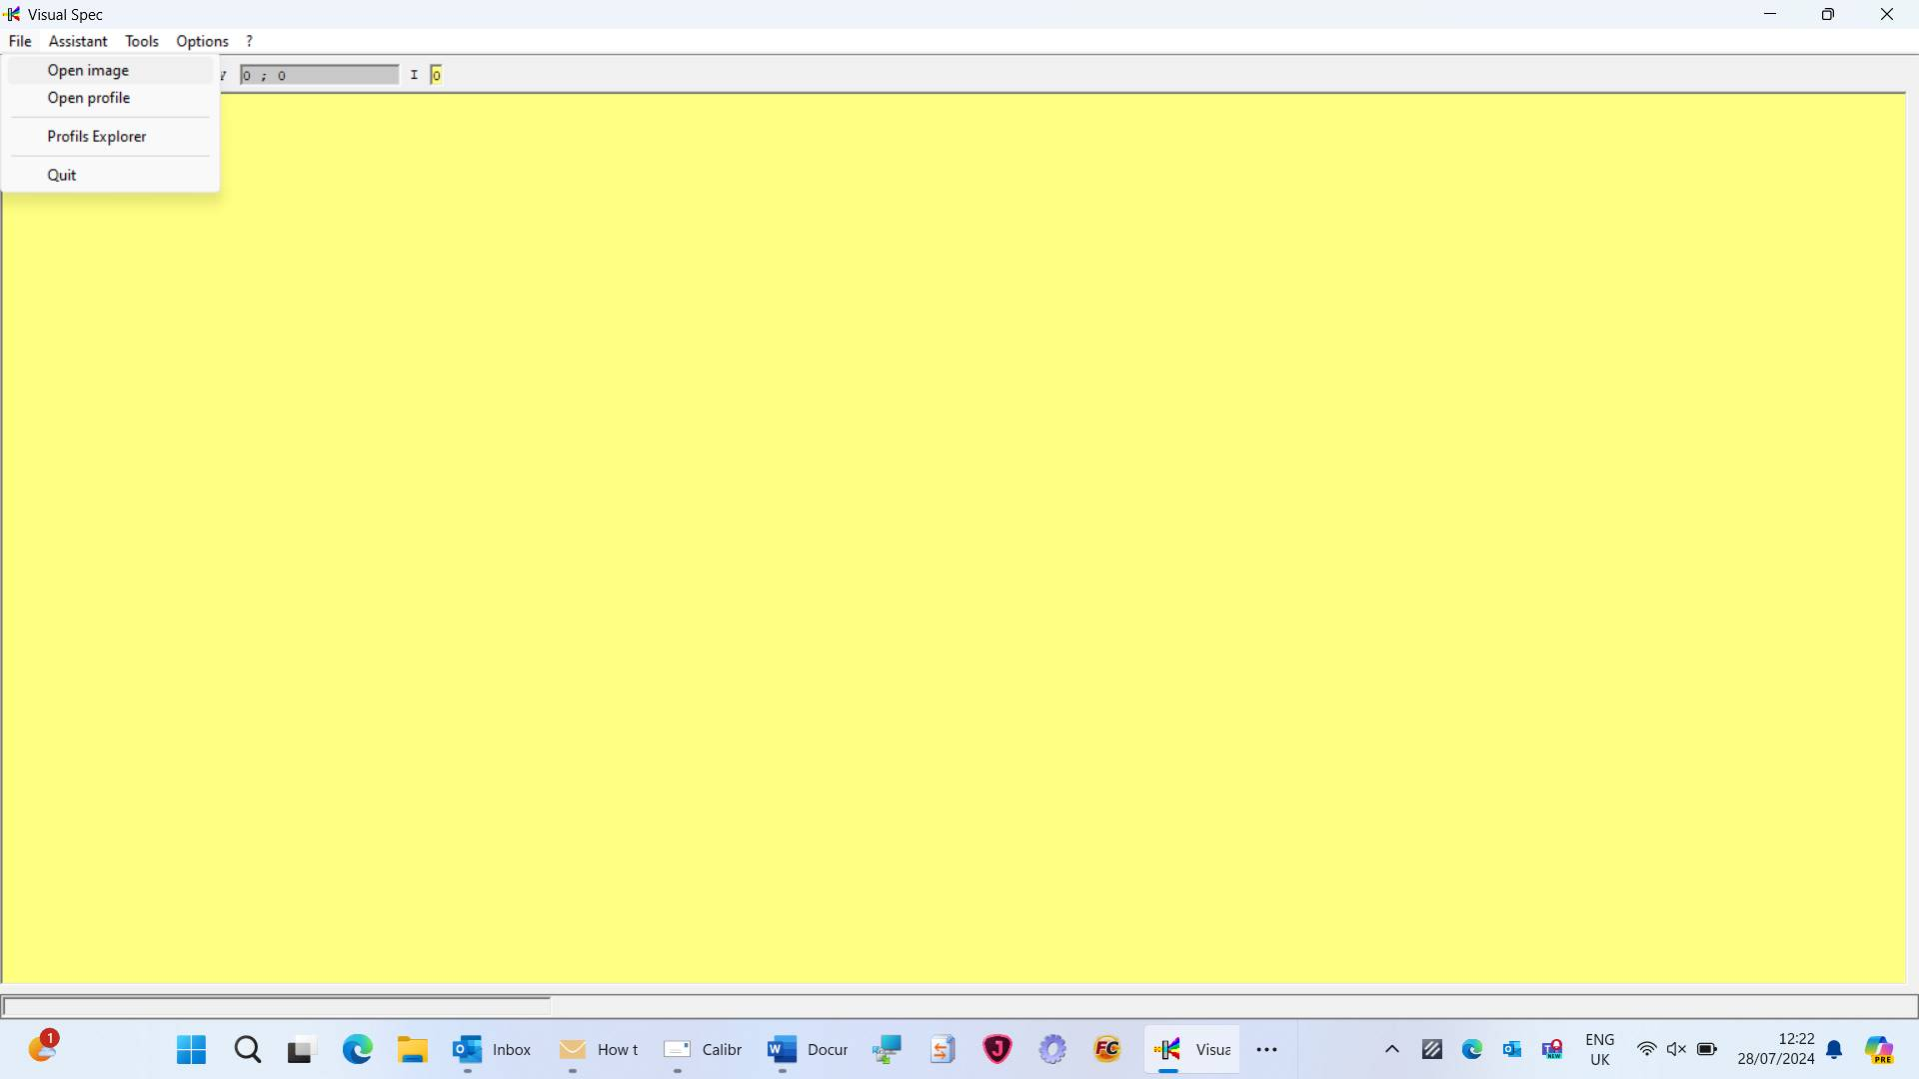

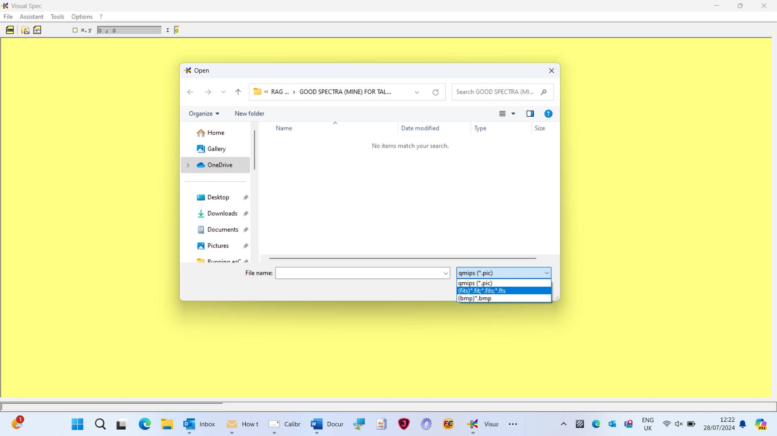

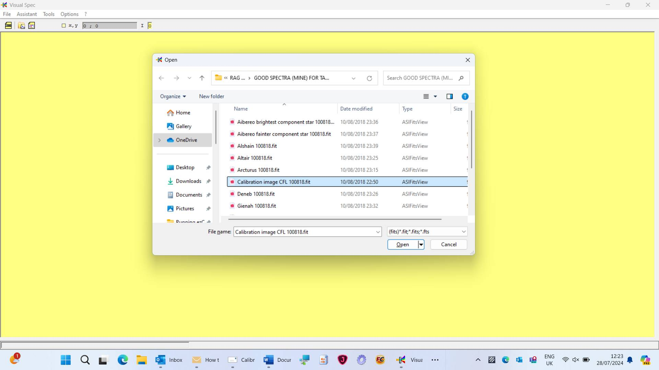

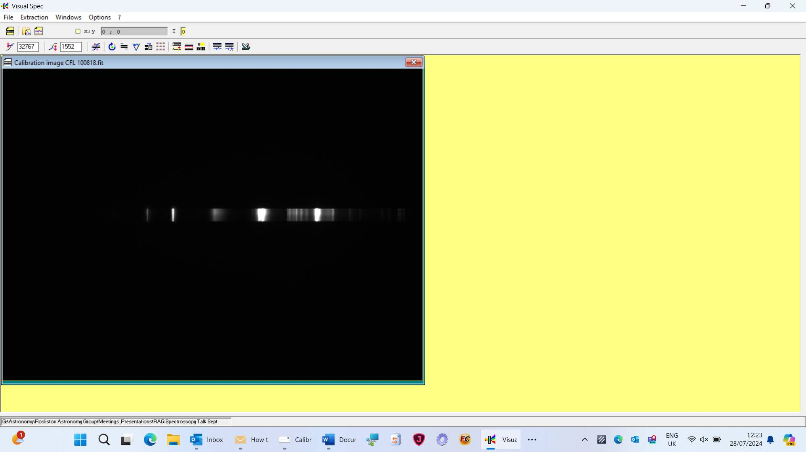

Extract spectrum:

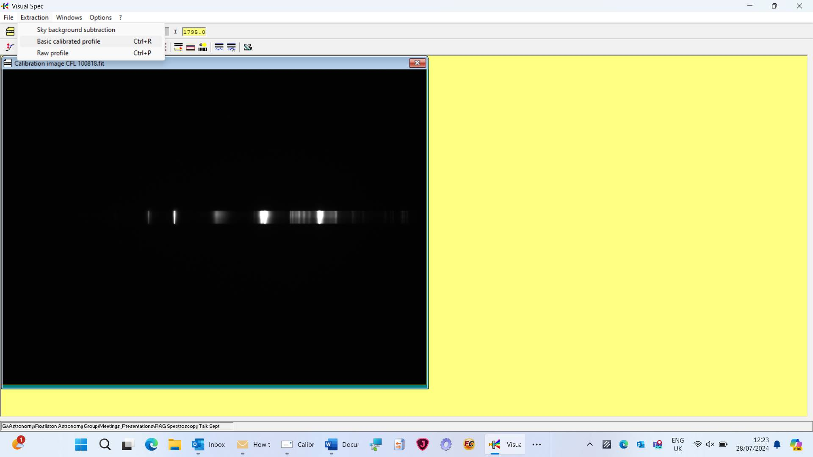

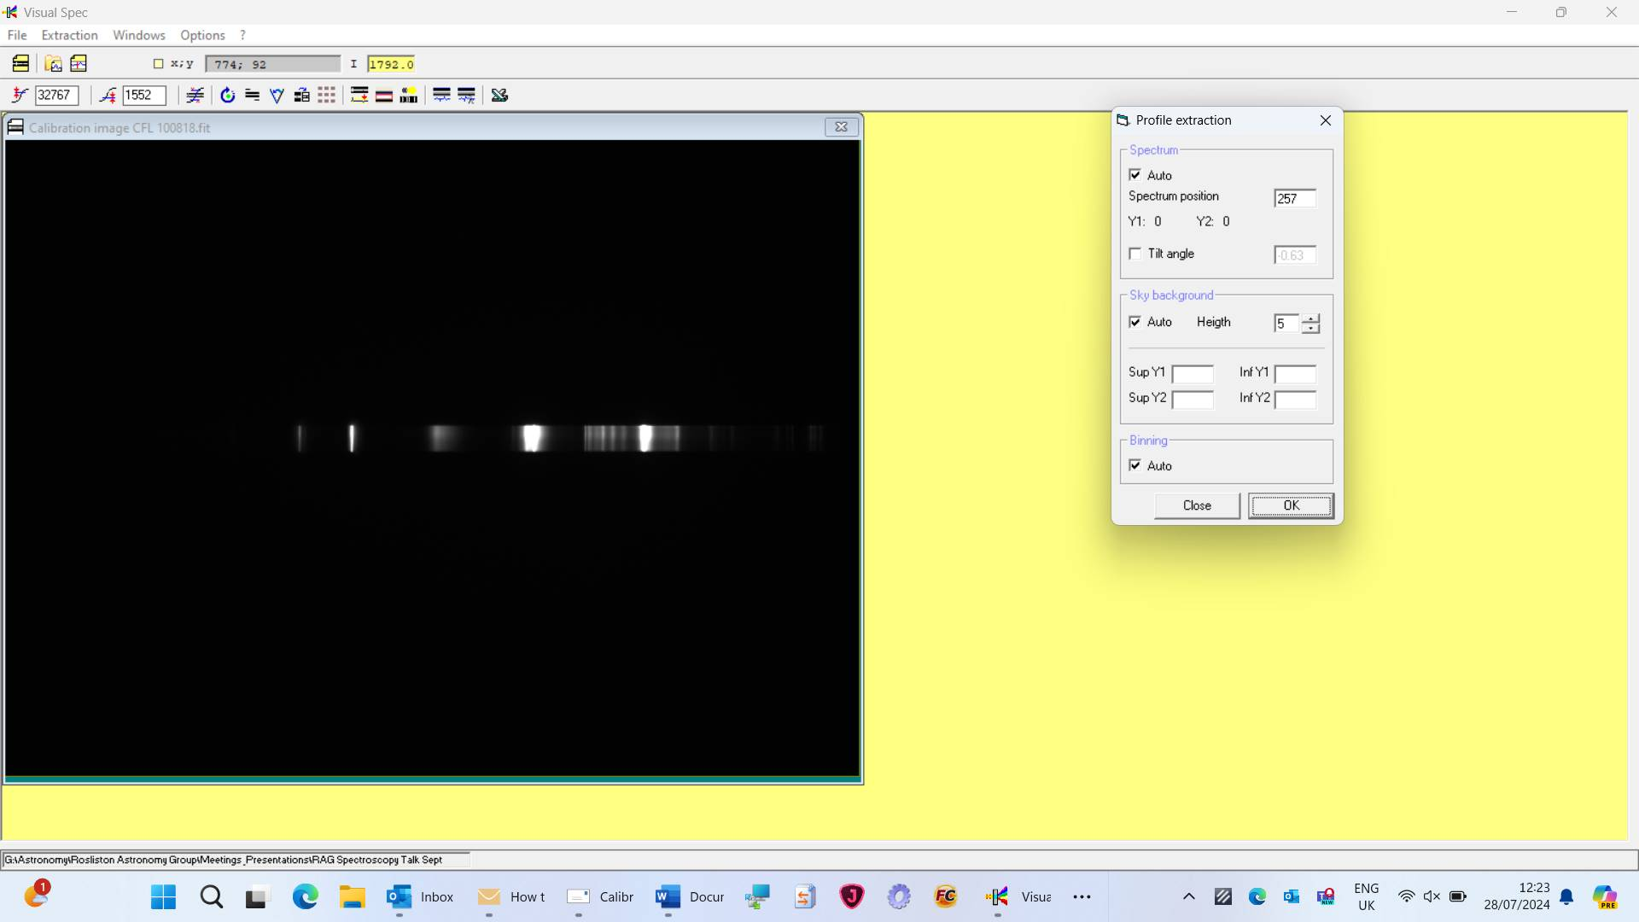

Press <OK>

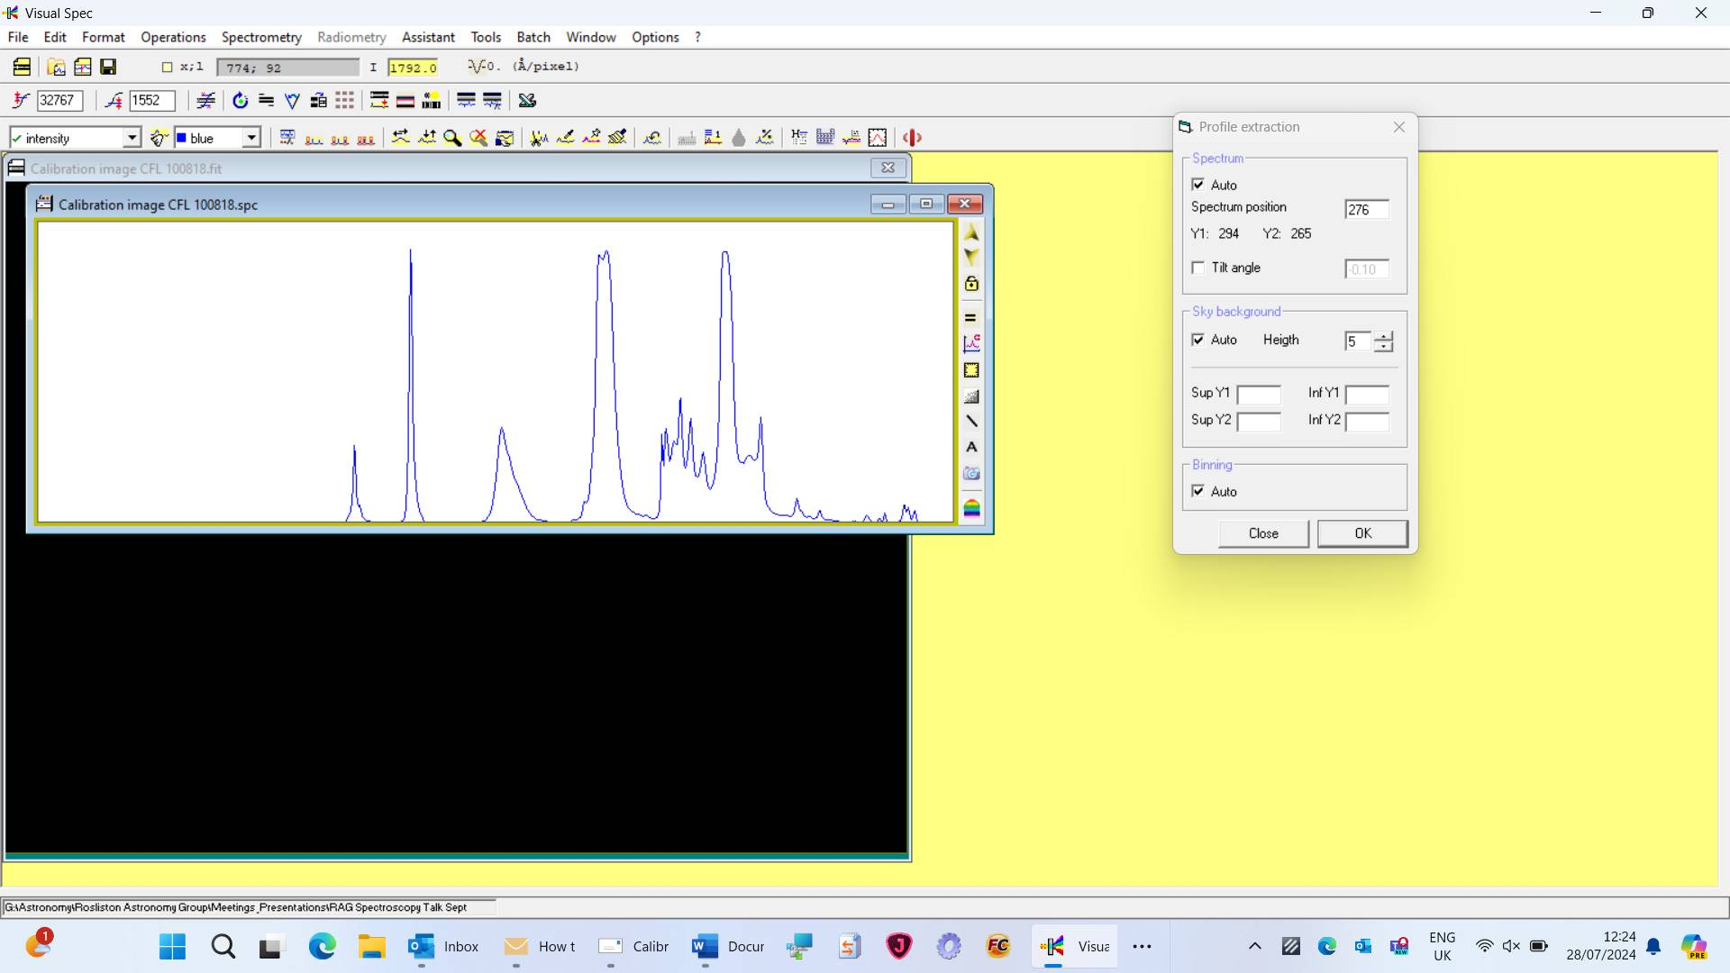

Close <profile> box down, to leave screen looking like below:

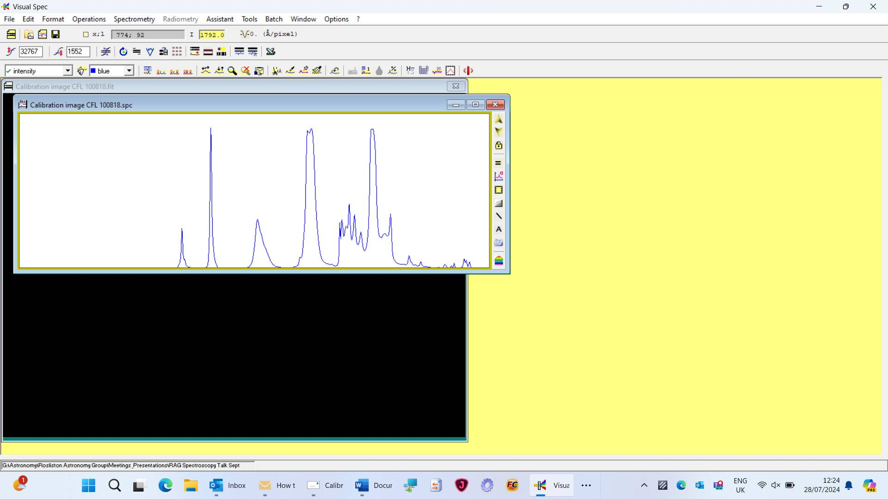

Click <Spectroscopy> then <basic calibration>

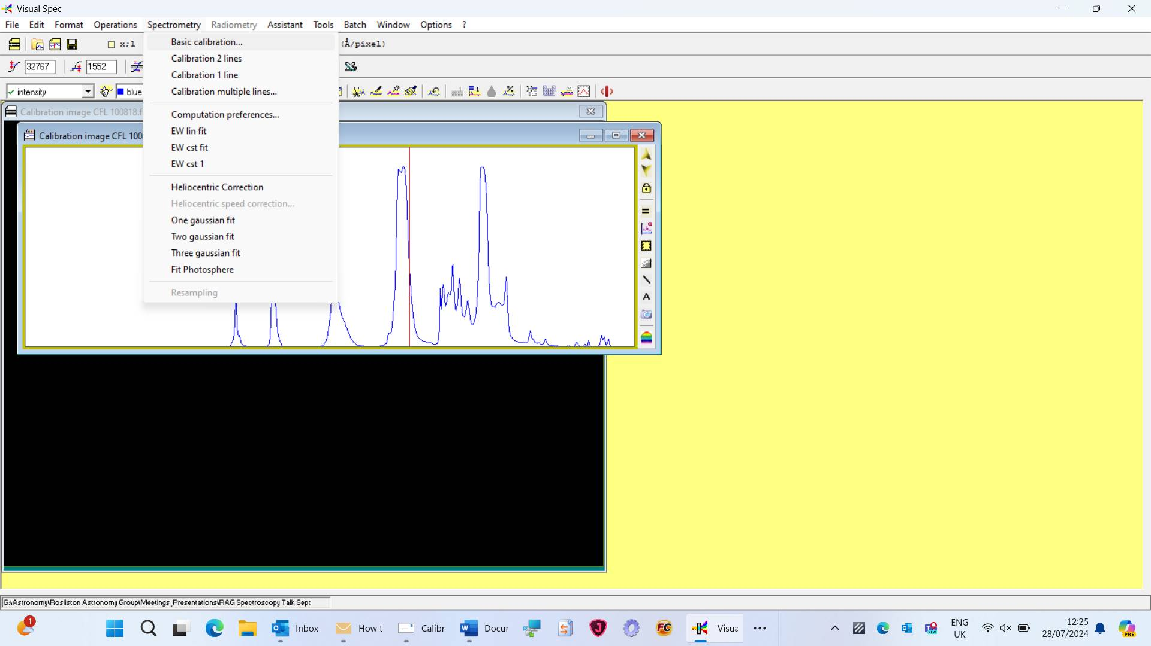

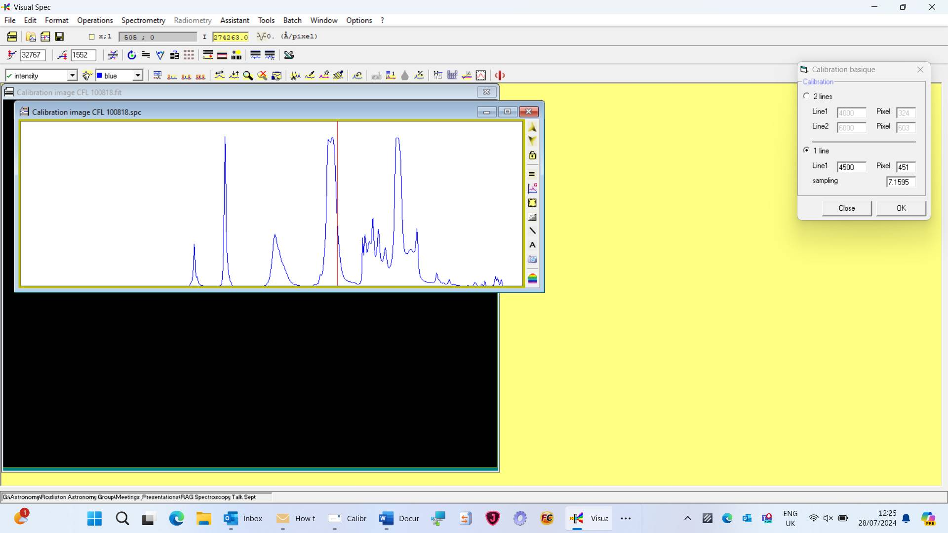

Select 2 lines and enter line values and pixel numbers – pixel numbers can be read on top line – move cursor on plot to see red line move around corresponding to pixel value. Choose 2 easily identifiable peaks that have known wavelengths and enter the wavelength next to line 1 and line in ANGSTROMS.

Press <OK> in <Calibration Basique>

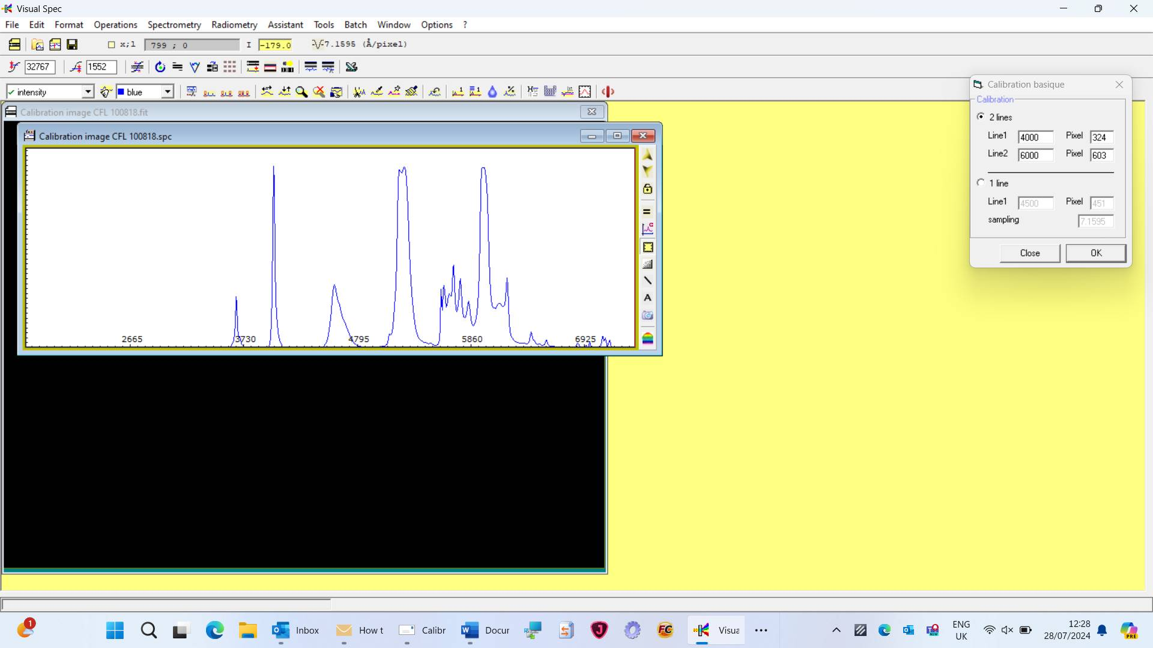

Now you can see the graph shows wavelength in angstroms on x-axis.

RECORD THE VALUE JUST TO RIGHT OF -V- (7.1595 BELOW) – THIS IS NEEDED IN NEXT STEP

Close <Calibration Basique> and calibration image to leave following:

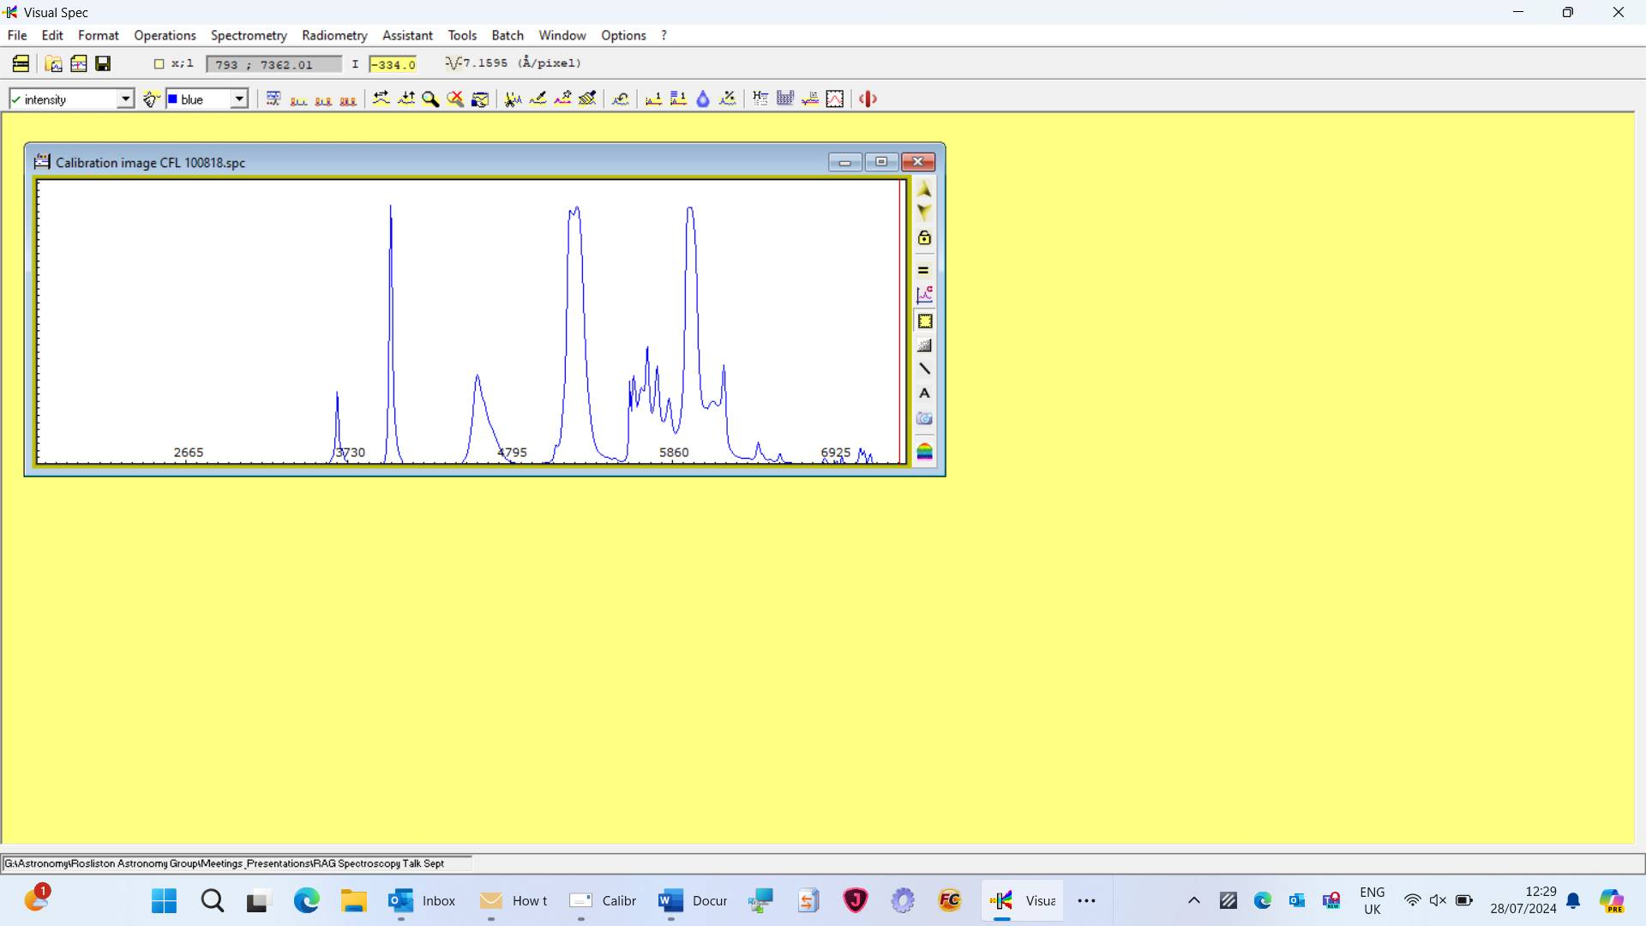

Open 2nd spectrum you wish to determine values of lines upon.

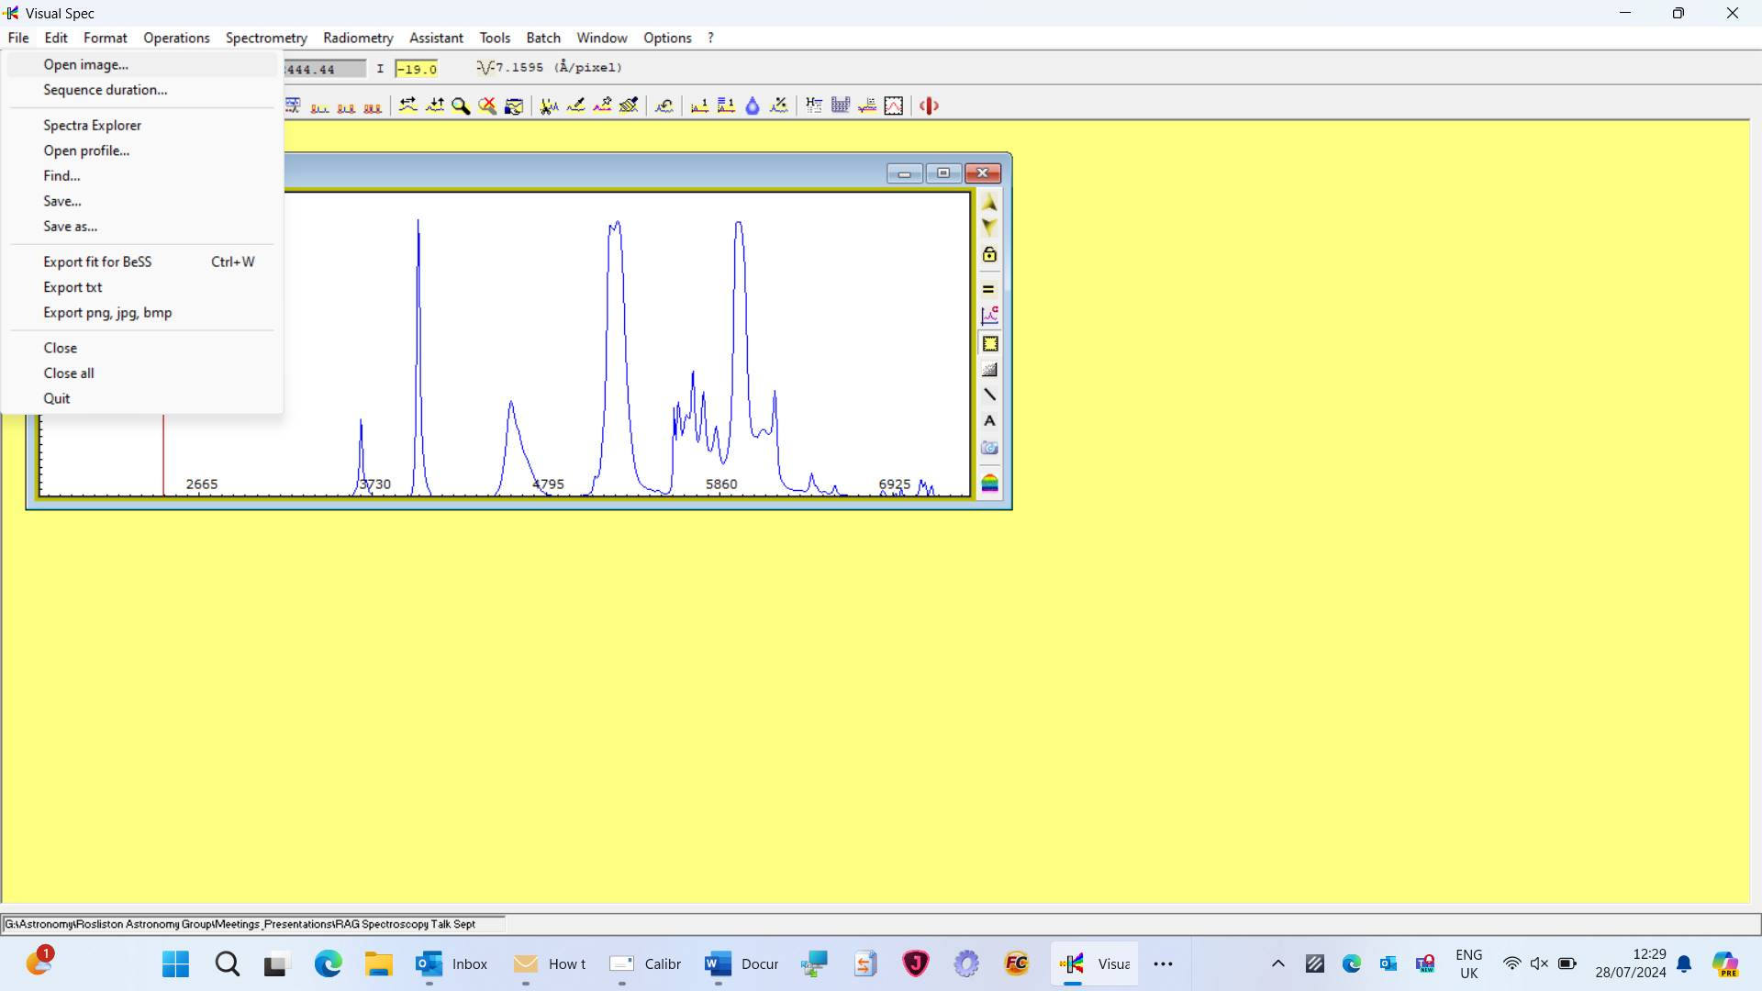

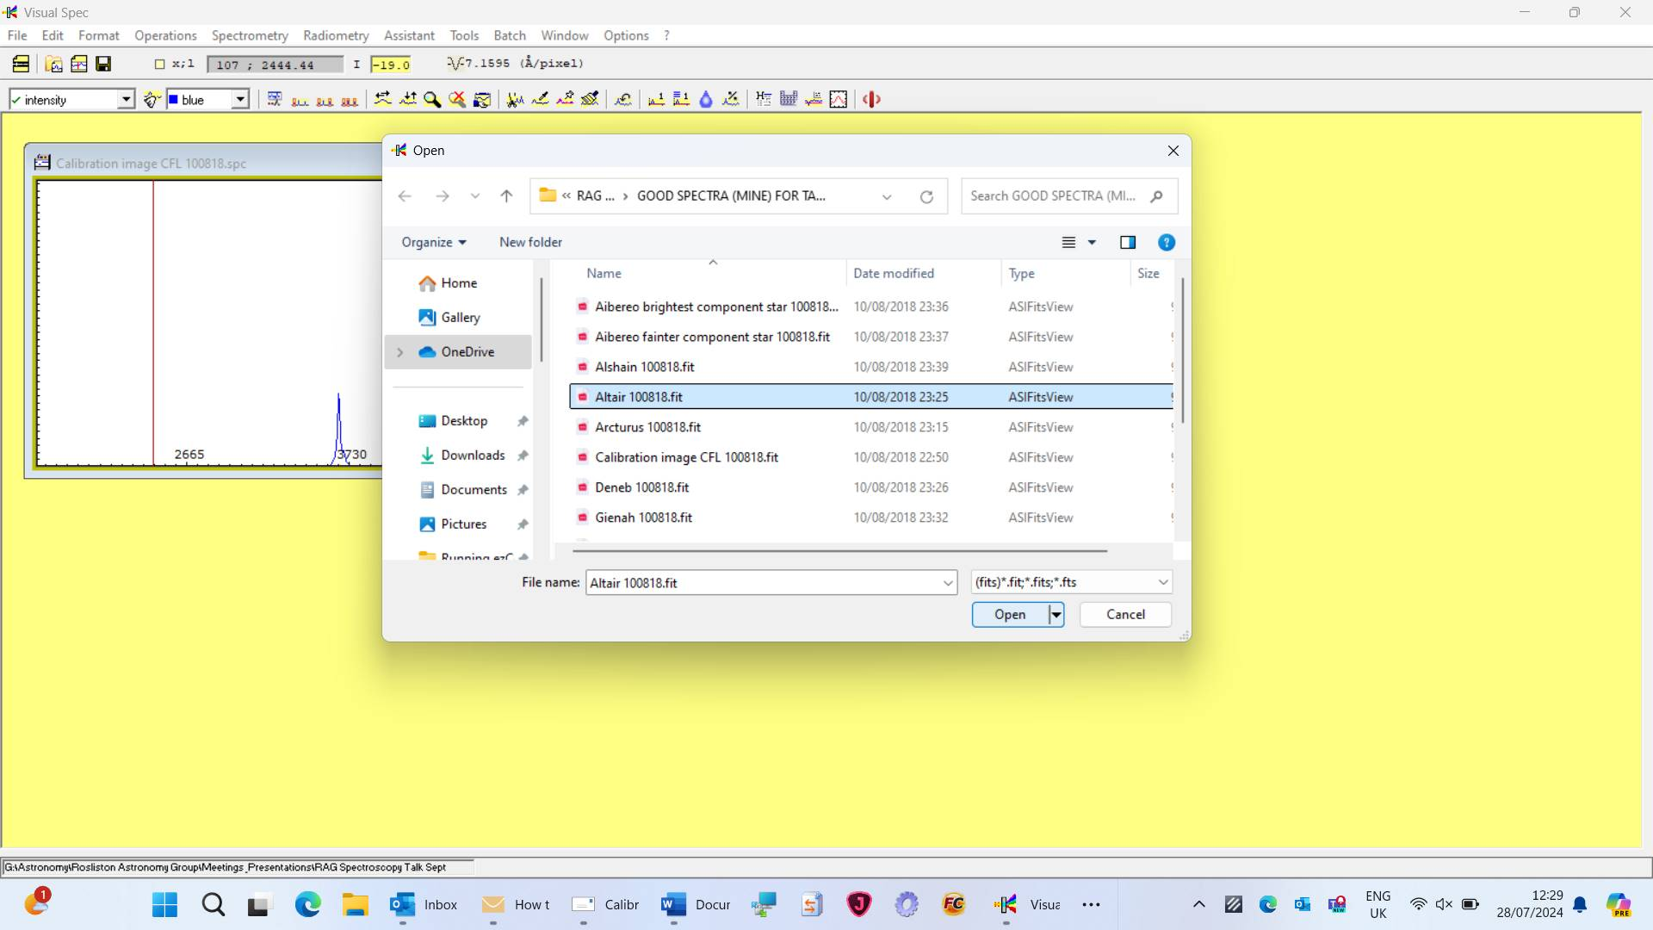

Click <Extraction> then <basic profile>

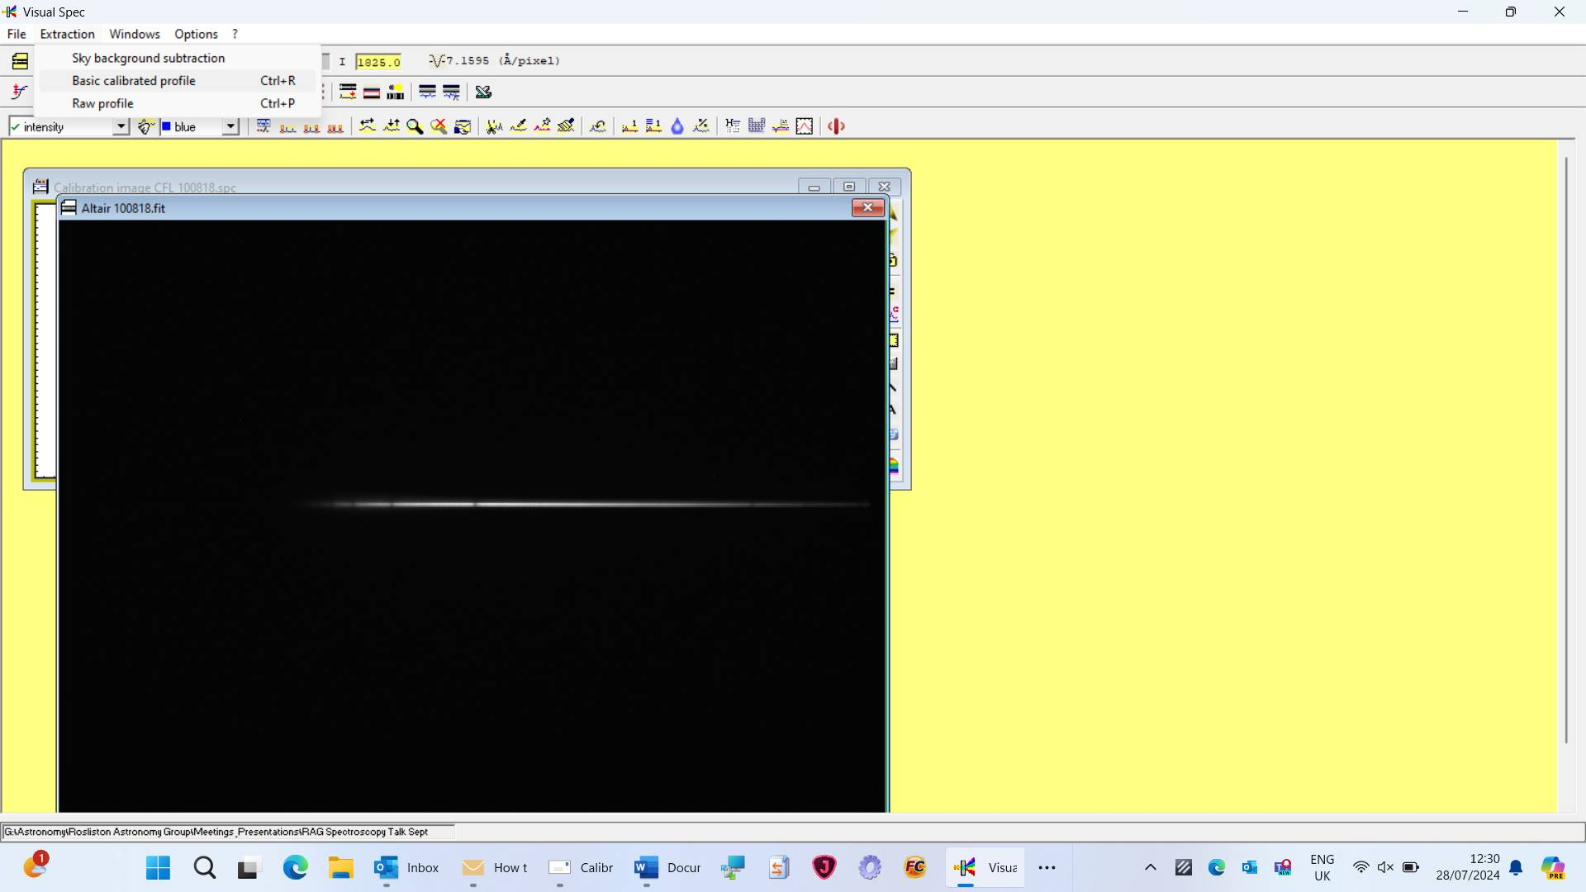

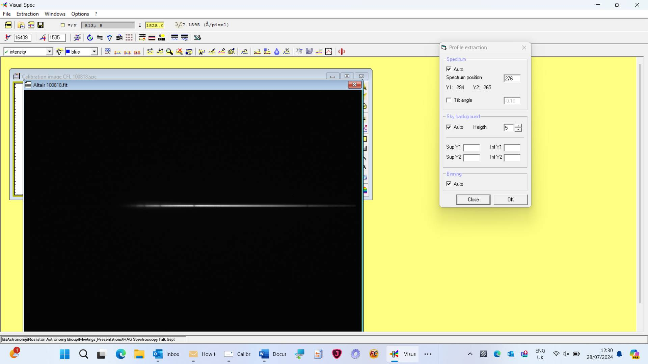

Click <OK>

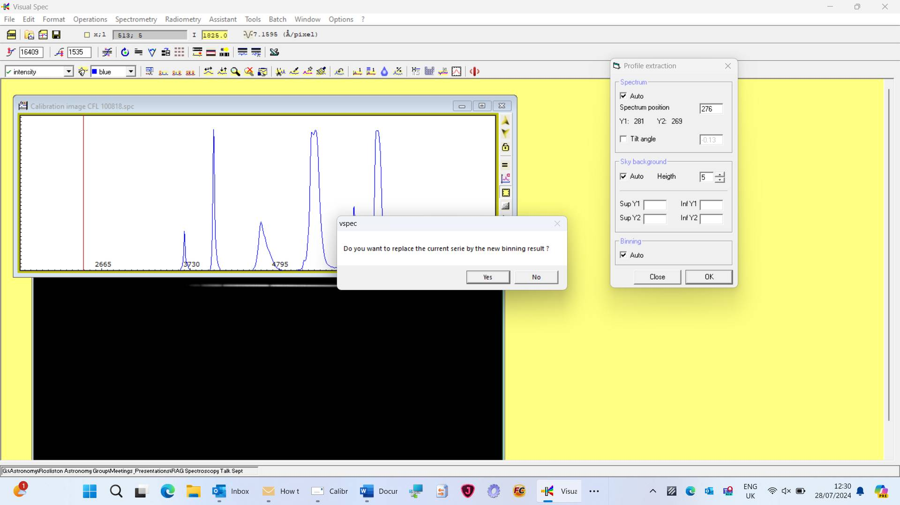

Click <NO> here

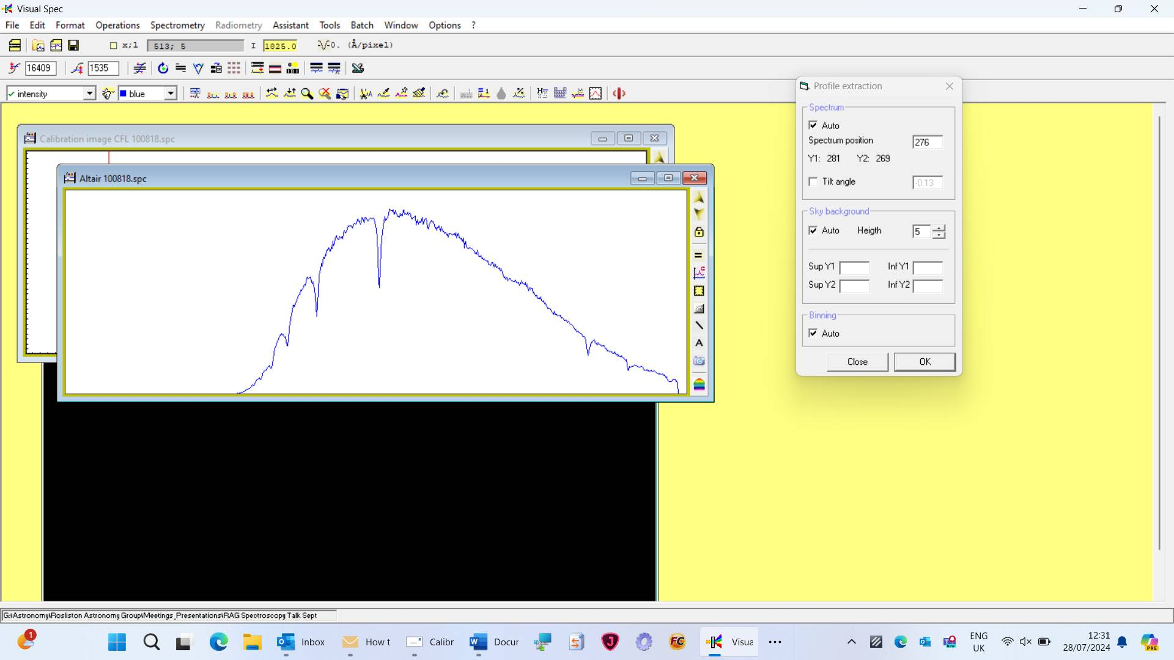

Close <Profile extraction> box and FIT file

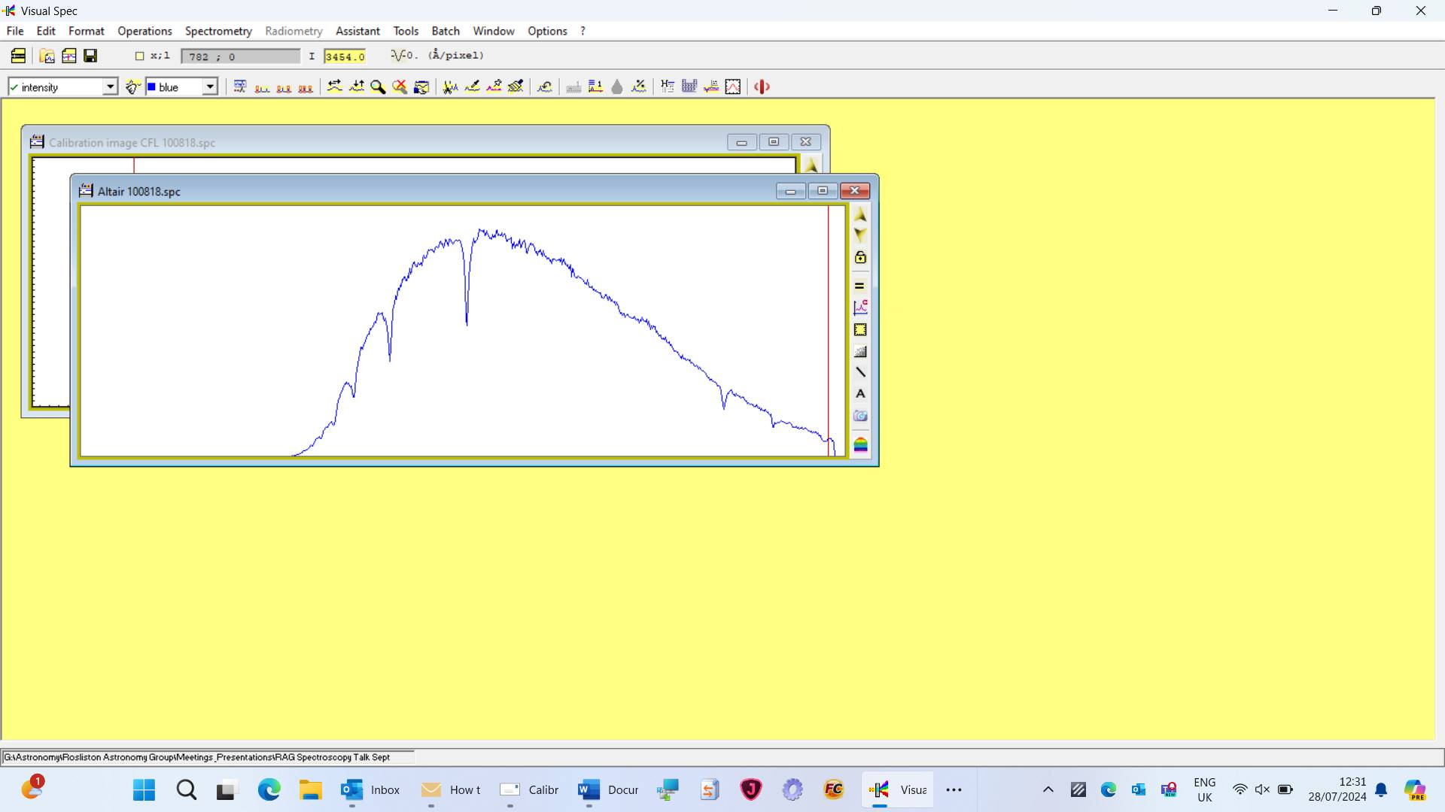

Click <Spectroscopy> then <basic profile> again

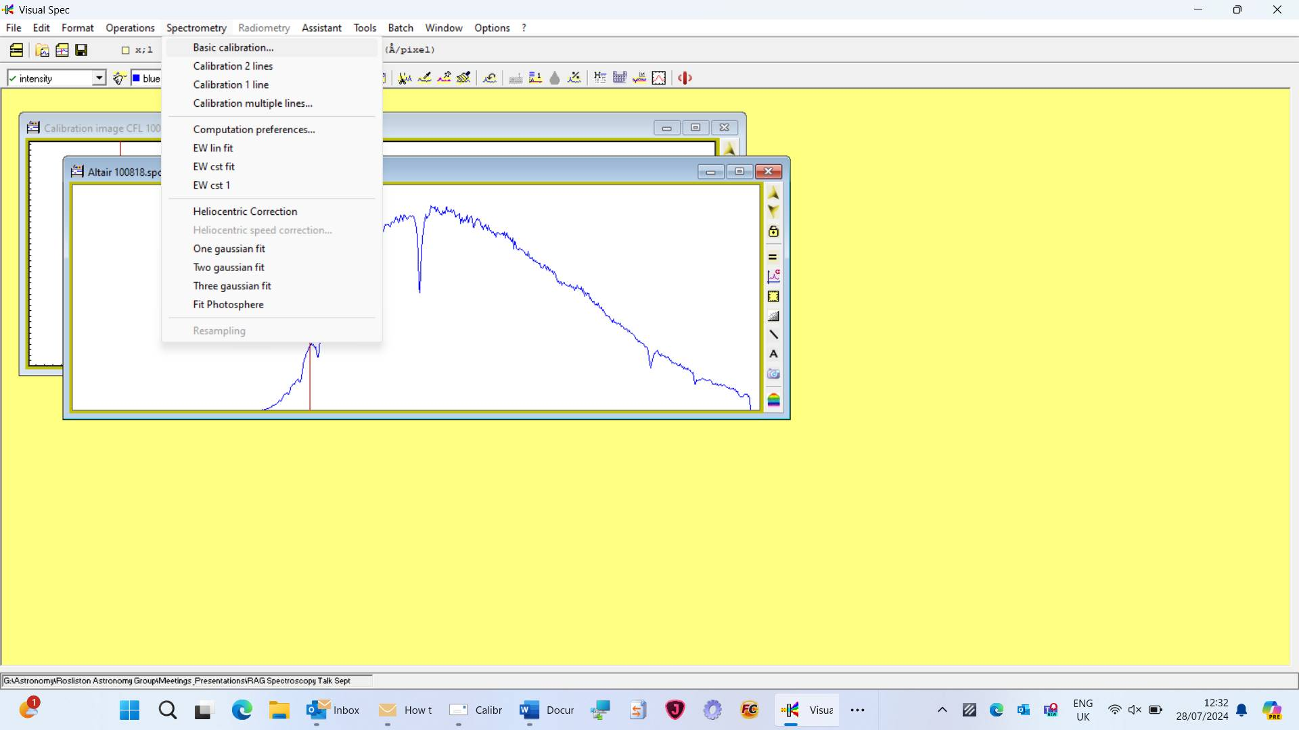

In <Calibration Basique> click one line and choose one identifiable line and enter pixel value and in sampling box enter the scale (7.1595 recorded earlier) – click <OK>.

The second spectrum is now calibrated in wavelength:

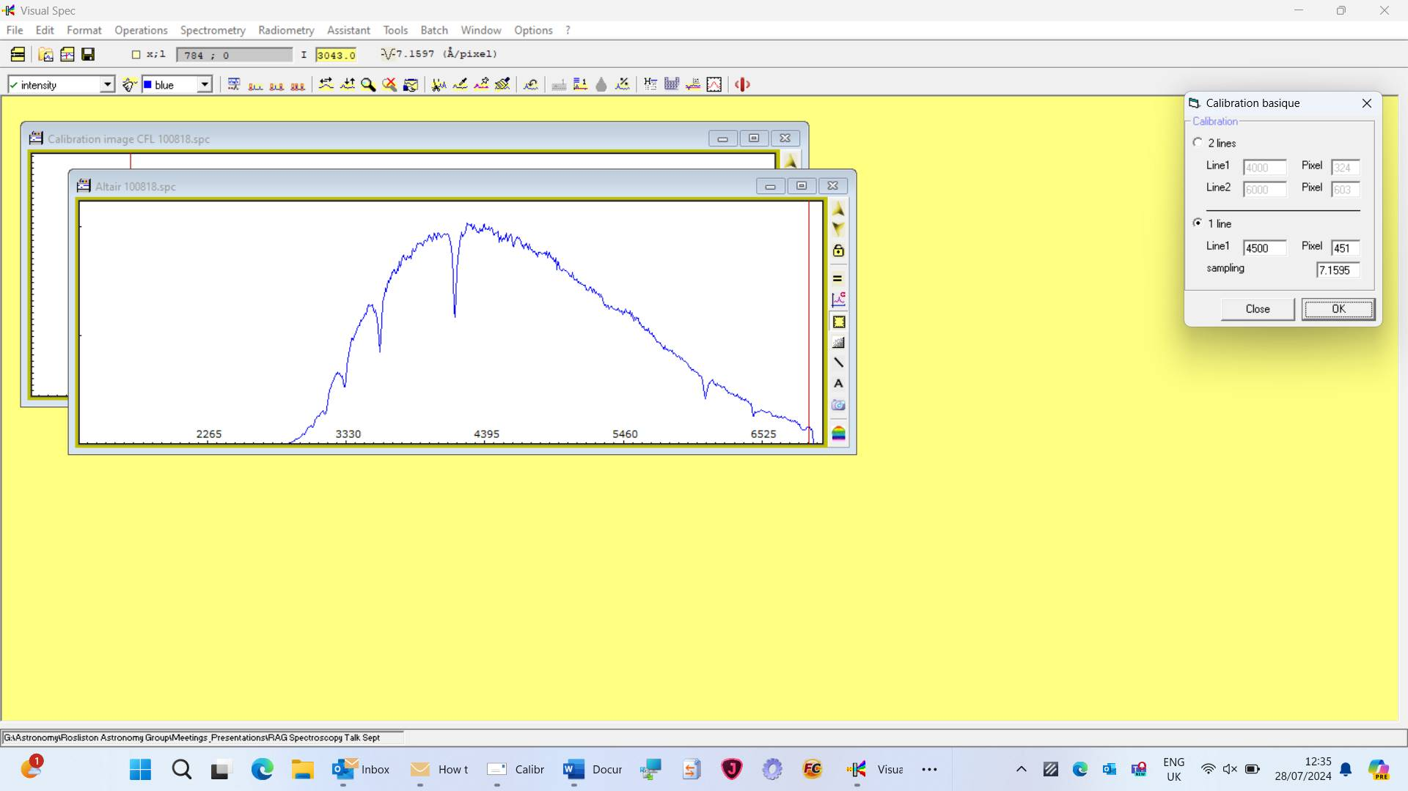

***Official VSPEC Tutorial Instructions on how to do calibration from*** [***http://www.astrosurf.com/vdesnoux/howto02.html***](http://www.astrosurf.com/vdesnoux/howto02.html)

image

|  |
| --- |
| ***From pixel to wavelength*** |
| Once the intensity curve is obtained, through binning, the next operation consists of establishing a relationship between pixel and wavelength. | |
| The composition of the light has been spread out by the spectroscope device according to wavelength. Depending of the mounting chosen, this relationship can be close to linear: an equal number of pixels correspond to an equal domain of wavelength. | |

***Theory of operationsimage***

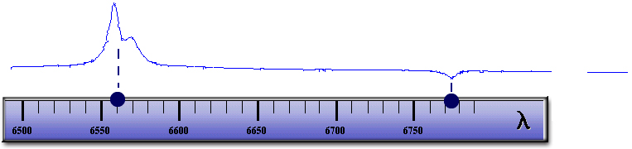

An equation links the pixel number to a specific wavelength:

|  |  |  |  |  |  |
| --- | --- | --- | --- | --- | --- |
|  |  |  |  |  |  |
|  |  | Wavelength = a*Pixel_number + b |  |  |  |
|  |  |  |  |  |  |
|  | Once this relationship is established for the optical combination of the spectroscope, this is more or less valid for all the spectra recorded with this very same combination.  The "a" coefficient is the sampling of your system. The higher it is, the highest resolution you have, this mean the easier it will be to separate lines when they close to each other. | | |  | However, it is strongly recommended to recompute the relation for each spectrum in order to eliminate small variations like mounting/dismounting, small mechanical displacements, telescope equilibrium, atmospheric transparency. |
|  |  |  |

***How to identify which intensity correspond to which wavelength?image***

Several options shall be considered:

|  |  |  |  |  |
| --- | --- | --- | --- | --- |
|  |  |  |  |  |
|  |  |  |  |  |
|  |  | image | [image](http://www.astrosurf.com/vdesnoux/howto02.html#spec) | **The spectrum itself shows easily identifiable lines which allow self-calibration** |
|  |  | [image](http://www.astrosurf.com/vdesnoux/howto02.html#ref) | **A spectrum of a well-known star which exhibits recognizable lines is recorded before or after the studied spectrum** |
|  |  | [image](http://www.astrosurf.com/vdesnoux/howto02.html#cal) | **The spectroscope assembly includes a calibration lamp** |
|  |  | | | | |
|  | image | | | | |
|  | The usage of a calibration lamp is the most accurate way to calibrate spectra. On the opposite, using the spectrum itself does not work properly in all cases and show low precision as it cannot account for doppler measurements. But this is probably the easiest one to start with. | | | | |

**image Wavelength calibration with the spectrum itself...**

|  |
| --- |
| This method works properly if at least two lines are easily identifiable. To calibrate the profile, you need to assign the right wavelength to each of the two lines and Visual Spec will do the rest by computing the linear fit for each pixel. As a result, each pixel will correspond to a wavelength and by dragging the cursor over the profile you will see displayed the corresponding wavelength.  image  *As the spectrum is calibrated by respect to itself, it will not be possible to measure doppler effect as it needs to take into account wavelength shift versus the absolute value which you do not have.* |

**image Wavelength calibration with a reference star...**

|  |
| --- |
| To calibrate the spectrum of the reference star, you need to identify two lines and to assign through Visual Spec their corresponding wavelength. Once this is done, you have to load the spectrum you want to calibrate. It is mandatory that this spectrum has been recorded in the very same conditions to not introduce errors. The assumption is that the sampling coefficient will be the same for both spectra. |
| image First step is to record the spectrum of a known star for reference, with lines easily identifiable. Then, this spectrum shall be calibrated. Once done, the sampling coefficient shall be recorded on a piece of paper.  image  *If the assembly does not allow to image domain beyond 6600 angstroms, it will not be possible to use atmospheric lines as they will not show up on the spectrum*. |
| image Now, the spectrum to calibrate is loaded, and it is sufficient to identify only one line. By entering the same sampling coefficient, the new spectrum will be calibrated as well, and by dragging the cursor over the spectrum, wavelength will be displayed  image |

**image Wavelength calibration with a calibration lamp...**

|  |  |  |  |  |  |  |  |
| --- | --- | --- | --- | --- | --- | --- | --- |
| The method is the same as for the reference star. But instead of using a star spectrum, this method uses the artificial light from a lamp which exhibits emission lines. By knowing the composition of the lamp, you can easily identify key lines and find in tables their wavelength.  In my past experience I used Argon lamp, but Neon lamp shall work as well. You just need to take care that the type of lamp you are using exhibits lines in the wavelength domain you are observing. In Infrared, Argon lamp does not have a lot of lines, which can be an issue at high resolution. | |  |  | | --- | --- | |  |  | |  | image | |  | This is the technic used by professionals. It will work for all types of spectra, in all type of optical combination. | |
| image | image Once the two spectra have been recorded, they shall be both reduced by binning into the same profile. As they were acquired in the same conditions, the Argon spectrum can be superimposed on the object spectrum, and Argon calibration will apply too. It is easiest to calibrate the Argon one, as emission lines can be found in laboratory tables. In Visual Spec, a library of such lines is included.  In this very special case, there is few lines present. The first approximation is done by knowing by construction which spectral domain is targeted. Usually, spectroscope includes such control, the rotation angle of the camera versus the grating is a first indication of the spectral domain.  The second approximation is that by shooting in the H-alpha region, the strong line in emission shown on the star which is a Be star is likely to be the H-alpha line.  By looking at which lines are around 656.3 nm on the argon spectrum, the two lines are likely to be the 606.4 nm and the 653.8 nm argon lines.  After wavelength calibration on the Argon spectrum, one checks that star emission line is well set at 656.3nm... |

image**The argon spectrum as per laboratory tables**

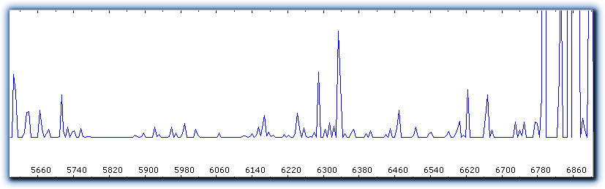

|  |  |
| --- | --- |
|  |  |
| image | |