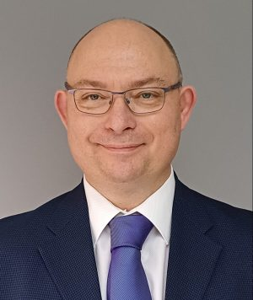

**DR ANDREW MARTYN THORNETT, M6THO**

Dr Andrew Thornett is a General Medical Practitioner in Birmingham with an eclectic interest and passion for all things astronomy. He is a member of the BAA Radio Astronomy Group and Society of Amateur Radio Astronomers in the USA, and of Rosliston Astronomy Group in Derbyshire, and the Astronomical Society of Penang in Malaysia.

[Linkedin](https://www.linkedin.com/in/melissa-gillone-phd-4a379042/)

**Mapping the Milky Way’s arms and demonstrating Dark Matter from your garden.**

Would you like to replicate the science behind much of the astronomy headlines? This talk will tell you how to do this for around £200 using readily-available off-the-shelf components. No electronics or amateur radio experience required!