Instructions for creating 4D images 10/12/2024

- For these instructions, I have used a folder called “LRO” (for Lichfield Radio Observatory). This can be changed to any preferred name. However, the “data” named sub-folder must have that name.
Batch files can be run directly as a batch as they identify the folder, they will be used on within the batch file.
Where there are individual commands below that need to be run on the command line, the command line should be accessed by doing the following:
Open the \ezRA_Programs+Data\ezRABase\LRO\ folder
In the navigation bar at the top, select all and type “CMD” <enter>
This bring up a command line box and the command can now be entered.

- Under the ezRABase folder structure, set up the sub-folder “LRO” with further sub-folder within “LRO” called “data”, i.e. \LRO\data. Copy .txt data files from ezCol into the “data” folder.

Folder structure should now be:
ezRA Software (Python Scripts) should be stored in:
\ezRA_Programs+Data\ezRABase\ezRA
Data (.txt) files generated by ezCol should be stored in:
\ezRA_Programs+Data\ezRABase\LRO\data

- Run following batch, to generate NPZ and EZB files, and a range of plots:
cd D:\ezRA_Programs+Data\ezRABase\LRO\
py ..\ezRA\ezCon.py -ezConAstroMath 1 data -ezRAObsLat 52.7 -ezRAObsLon -1.8 -ezRAObsAmsl 81.0 -ezRAObsName LRO -ezConGalCrossingGLonCenterL 20 90 15 -ezConGalCrossingGLonNear 2.0
py ..\ezRA\ezPlot.py .
py ..\ezRA\ezSky.py . -ezSkyVOGain 200
py ..\ezRA\ezSky.py . -ezSkyVOGain 200 -ezSkyInput 18
py ..\ezRA\ezGal.py .
py ..\ezRA\ezGLon.py . -ezGLonGalCrossingGLonCenterL 20 90 15

The following is an example of output of the above, in terms of NPZ and EZB files.

Directory of D:\ezRA_Programs+Data\ezRABase\LRO:

29/11/2024 07:55 10,052,229 LRO240219_19_Array_El_88-7_Az_163.ezb
29/11/2024 07:55 29,073 LRO240219_19_Array_El_88-7_Az_163P00.0Gal.npz
29/11/2024 07:56 28,414 LRO240219_19_Array_El_88-7_Az_163P00.0GalC.npz
29/11/2024 07:55 33,779 LRO240219_19_Array_El_88-7_Az_163P080.0GLon.npz
29/11/2024 07:55 48,180 LRO240219_19_Array_El_88-7_Az_163P085.0GLon.npz
29/11/2024 07:55 58,129 LRO240219_19_Array_El_88-7_Az_163P090.0GLon.npz
29/11/2024 09:27 12,141,773 LRO240405_00_El_51-4_Az_163.ezb
29/11/2024 09:28 69,271 LRO240405_00_El_51-4_Az_163P00.0Gal.npz
29/11/2024 09:30 68,612 LRO240405_00_El_51-4_Az_163P00.0GalC.npz
29/11/2024 09:28 17,421 LRO240405_00_El_51-4_Az_163P020.0GLon.npz
29/11/2024 09:28 28,112 LRO240405_00_El_51-4_Az_163P025.0GLon.npz
29/11/2024 09:28 36,589 LRO240405_00_El_51-4_Az_163P030.0GLon.npz
29/11/2024 09:28 46,558 LRO240405_00_El_51-4_Az_163P035.0GLon.npz
29/11/2024 09:28 58,223 LRO240405_00_El_51-4_Az_163P040.0GLon.npz
29/11/2024 09:28 75,135 LRO240405_00_El_51-4_Az_163P045.0GLon.npz
29/11/2024 09:28 87,006 LRO240405_00_El_51-4_Az_163P050.0GLon.npz
29/11/2024 09:28 97,004 LRO240405_00_El_51-4_Az_163P055.0GLon.npz
29/11/2024 09:28 106,153 LRO240405_00_El_51-4_Az_163P060.0GLon.npz
29/11/2024 09:28 112,288 LRO240405_00_El_51-4_Az_163P065.0GLon.npz
29/11/2024 09:28 117,867 LRO240405_00_El_51-4_Az_163P070.0GLon.npz
29/11/2024 09:28 121,694 LRO240405_00_El_51-4_Az_163P075.0GLon.npz
29/11/2024 09:28 125,630 LRO240405_00_El_51-4_Az_163P080.0GLon.npz
29/11/2024 09:28 127,826 LRO240405_00_El_51-4_Az_163P085.0GLon.npz
29/11/2024 09:28 131,308 LRO240405_00_El_51-4_Az_163P090.0GLon.npz

- If above is ran on multiple batches of data files in different folders (e.g. LRO1, LRO2, LRO3….) then combine the resulting NPZ and EZB files into one folder.

- Now run the following command, with the XX replaced by angle you wish to perform the command for – e.g. 60:

py ..\ezRA\ezGLon241118a.py . -ezGLonGalCrossingGLonNear 2 -ezGLonPlotRangeL 580 580 -ezGLon580CsvFrac 0.15 -ezGLonGalCrossingGLonCenter XX
So, if XX is replaced with angle 60 then command becomes py ..\ezRA\ezGLon241118a.py . -ezGLonGalCrossingGLonNear 2 -ezGLonPlotRangeL 580 580 -ezGLon580CsvFrac 0.15 -ezGLonGalCrossingGLonCenter 60

The above needs to be repeatedly run for different angles. To help with this process, I have written this batch file: BATCH processing ezGLon for range angles on .txt data:
cd D:\ezRA_Programs+Data\ezRABase\LRO\
py ..\ezRA\ezGLon241118a.py . -ezGLonGalCrossingGLonNear 2 -ezGLonPlotRangeL 580 580 -ezGLon580CsvFrac 0.15 -ezGLonGalCrossingGLonCenter 90
py ..\ezRA\ezGLon241118a.py . -ezGLonGalCrossingGLonNear 2 -ezGLonPlotRangeL 580 580 -ezGLon580CsvFrac 0.15 -ezGLonGalCrossingGLonCenter 85
py ..\ezRA\ezGLon241118a.py . -ezGLonGalCrossingGLonNear 2 -ezGLonPlotRangeL 580 580 -ezGLon580CsvFrac 0.15 -ezGLonGalCrossingGLonCenter 80
py ..\ezRA\ezGLon241118a.py . -ezGLonGalCrossingGLonNear 2 -ezGLonPlotRangeL 580 580 -ezGLon580CsvFrac 0.15 -ezGLonGalCrossingGLonCenter 75
py ..\ezRA\ezGLon241118a.py . -ezGLonGalCrossingGLonNear 2 -ezGLonPlotRangeL 580 580 -ezGLon580CsvFrac 0.15 -ezGLonGalCrossingGLonCenter 70
py ..\ezRA\ezGLon241118a.py . -ezGLonGalCrossingGLonNear 2 -ezGLonPlotRangeL 580 580 -ezGLon580CsvFrac 0.15 -ezGLonGalCrossingGLonCenter 65
py ..\ezRA\ezGLon241118a.py . -ezGLonGalCrossingGLonNear 2 -ezGLonPlotRangeL 580 580 -ezGLon580CsvFrac 0.15 -ezGLonGalCrossingGLonCenter 60
py ..\ezRA\ezGLon241118a.py . -ezGLonGalCrossingGLonNear 2 -ezGLonPlotRangeL 580 580 -ezGLon580CsvFrac 0.15 -ezGLonGalCrossingGLonCenter 55
py ..\ezRA\ezGLon241118a.py . -ezGLonGalCrossingGLonNear 2 -ezGLonPlotRangeL 580 580 -ezGLon580CsvFrac 0.15 -ezGLonGalCrossingGLonCenter 50
py ..\ezRA\ezGLon241118a.py . -ezGLonGalCrossingGLonNear 2 -ezGLonPlotRangeL 580 580 -ezGLon580CsvFrac 0.15 -ezGLonGalCrossingGLonCenter 45
py ..\ezRA\ezGLon241118a.py . -ezGLonGalCrossingGLonNear 2 -ezGLonPlotRangeL 580 580 -ezGLon580CsvFrac 0.15 -ezGLonGalCrossingGLonCenter 40
py ..\ezRA\ezGLon241118a.py . -ezGLonGalCrossingGLonNear 2 -ezGLonPlotRangeL 580 580 -ezGLon580CsvFrac 0.15 -ezGLonGalCrossingGLonCenter 35
PAUSE

The following is an example of output of the above. CSV and PNG files are generated. These CSV files can now be opened in Rinearn3D.

Directory of D:\ezRA_Programs+Data\ezRABase\LRO:

10/12/2024 22:23 384,191 ezGLon580galArmsSunIP045.0P002.0.csv
10/12/2024 22:23 220,369 ezGLon580galArmsSunIP045.0P002.0.png
10/12/2024 22:22 468,266 ezGLon580galArmsSunIP050.0P002.0.csv
10/12/2024 22:22 231,028 ezGLon580galArmsSunIP050.0P002.0.png
10/12/2024 22:21 496,949 ezGLon580galArmsSunIP055.0P002.0.csv
10/12/2024 22:21 245,465 ezGLon580galArmsSunIP055.0P002.0.png
10/12/2024 22:20 489,283 ezGLon580galArmsSunIP060.0P002.0.csv
10/12/2024 22:20 243,059 ezGLon580galArmsSunIP060.0P002.0.png
10/12/2024 22:18 446,906 ezGLon580galArmsSunIP065.0P002.0.csv
10/12/2024 22:18 244,749 ezGLon580galArmsSunIP065.0P002.0.png
10/12/2024 22:17 376,228 ezGLon580galArmsSunIP070.0P002.0.csv
10/12/2024 22:17 238,391 ezGLon580galArmsSunIP070.0P002.0.png

It is helpful to combine the CSV files into a single file which can then be opened in Rinearn3D. This is done by running the following command from command line (CMD):
TYPE ezGLon580*.csv > ezGLonAll580.csv
This generates a single combined file within “LRO” folder called ezGLonAll580.csv which can be opened in Rinearn3D.
Run “rinearn3D.bat” file within \ezRABase\rinearn3d programme folder.
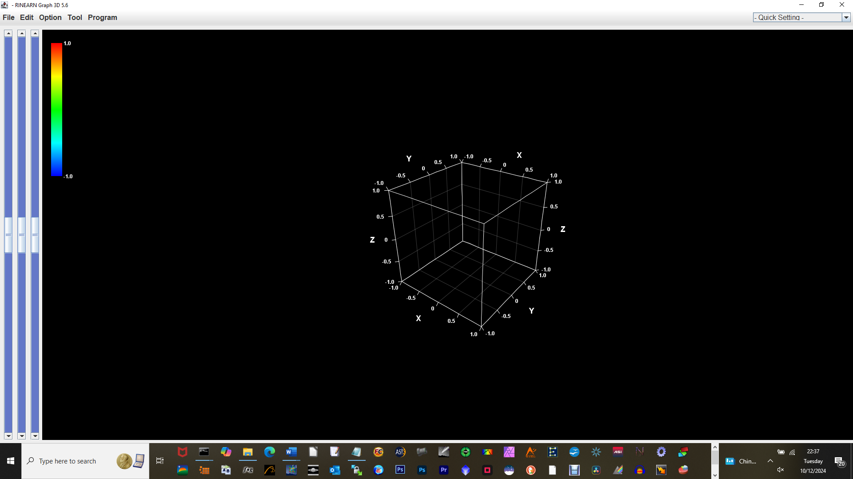
Click <file> - <open file>
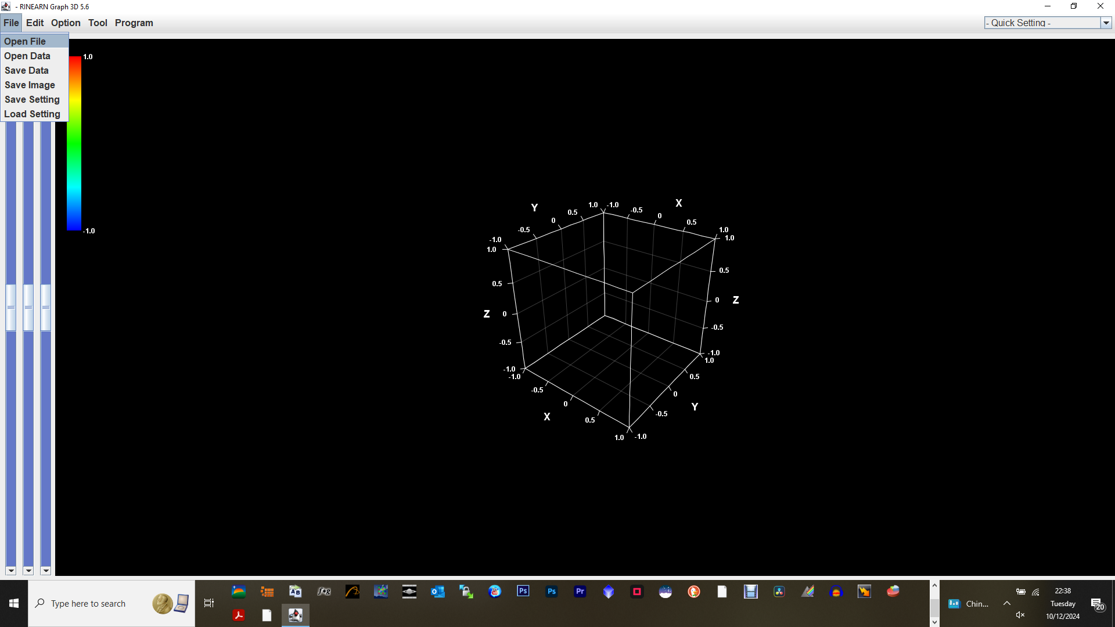
To bring up following:
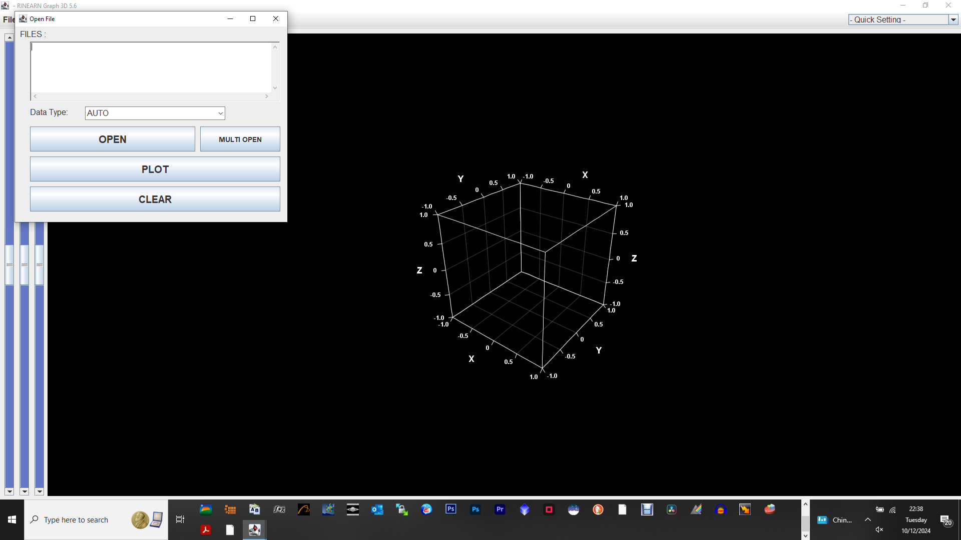
Click <open> and navigate to the ezGLonAll580.csv and select that file and double click on it.
File now appears in open box.
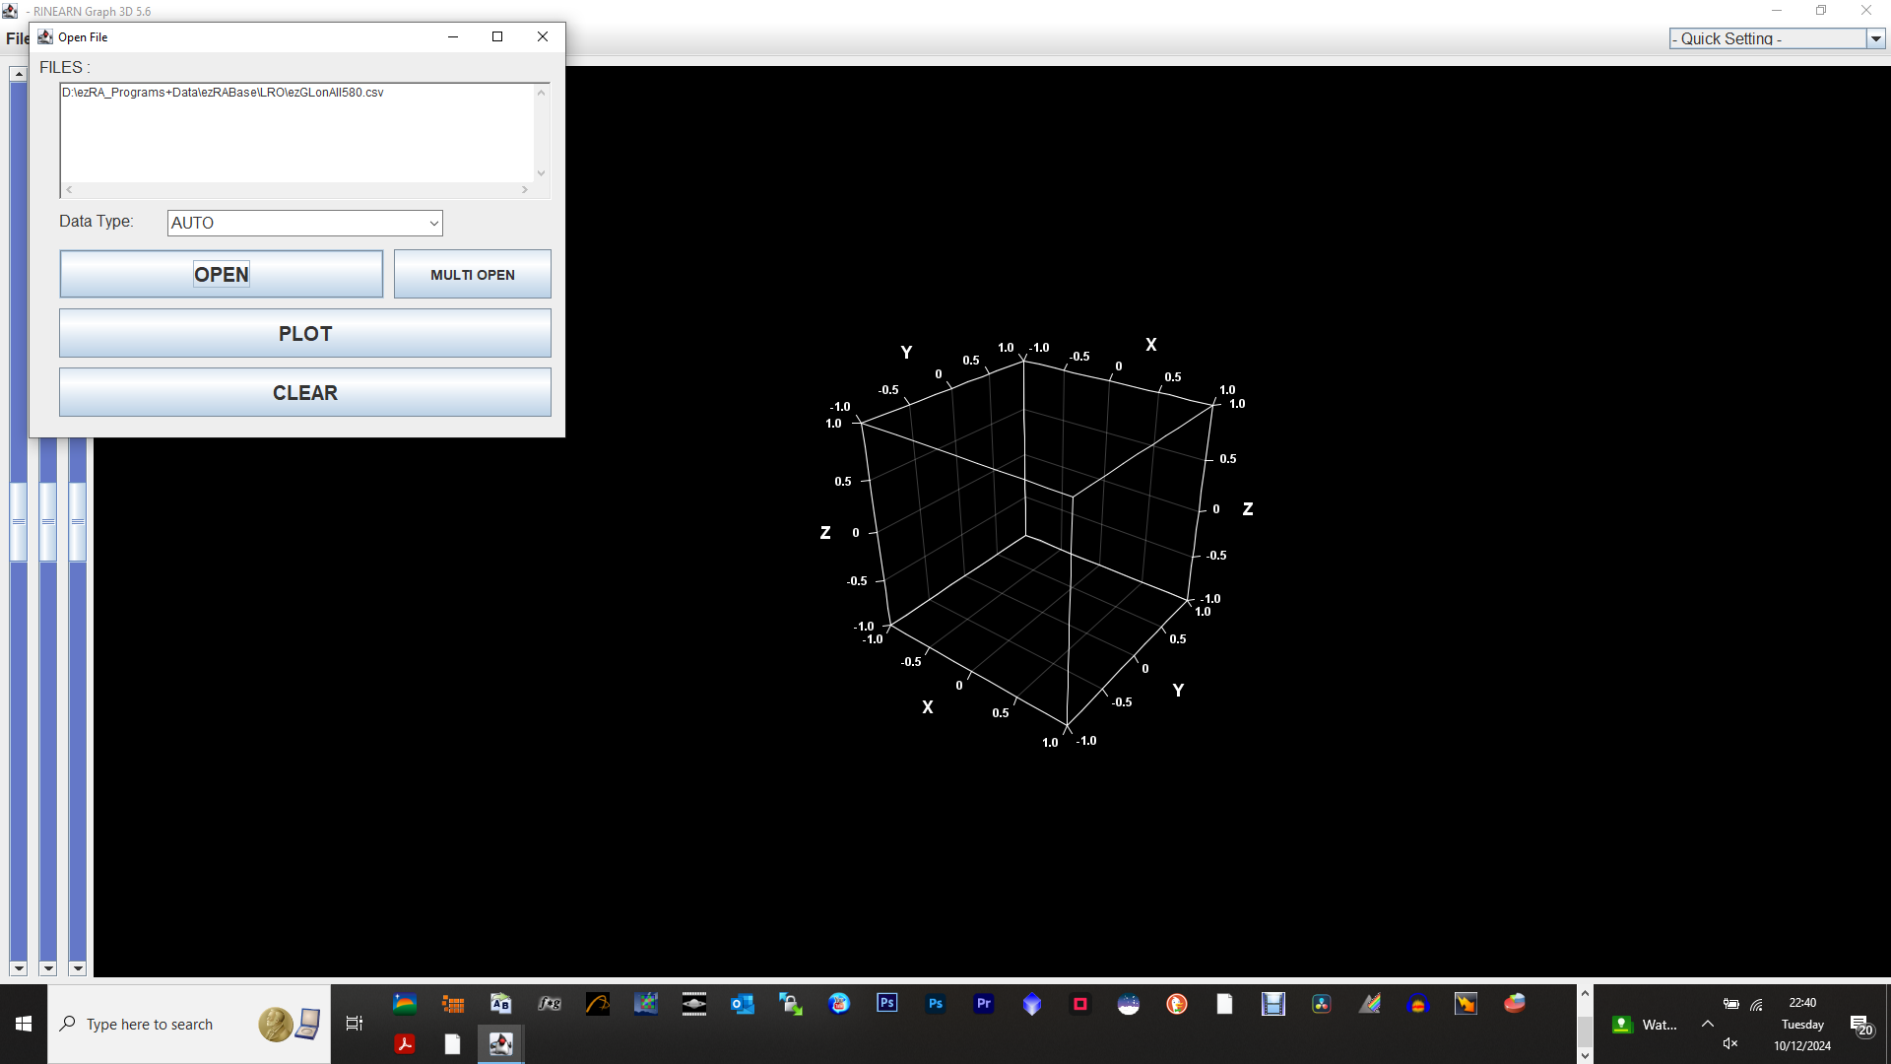
Click <plot> and select <4 columns>.
After a short while, plot appears:
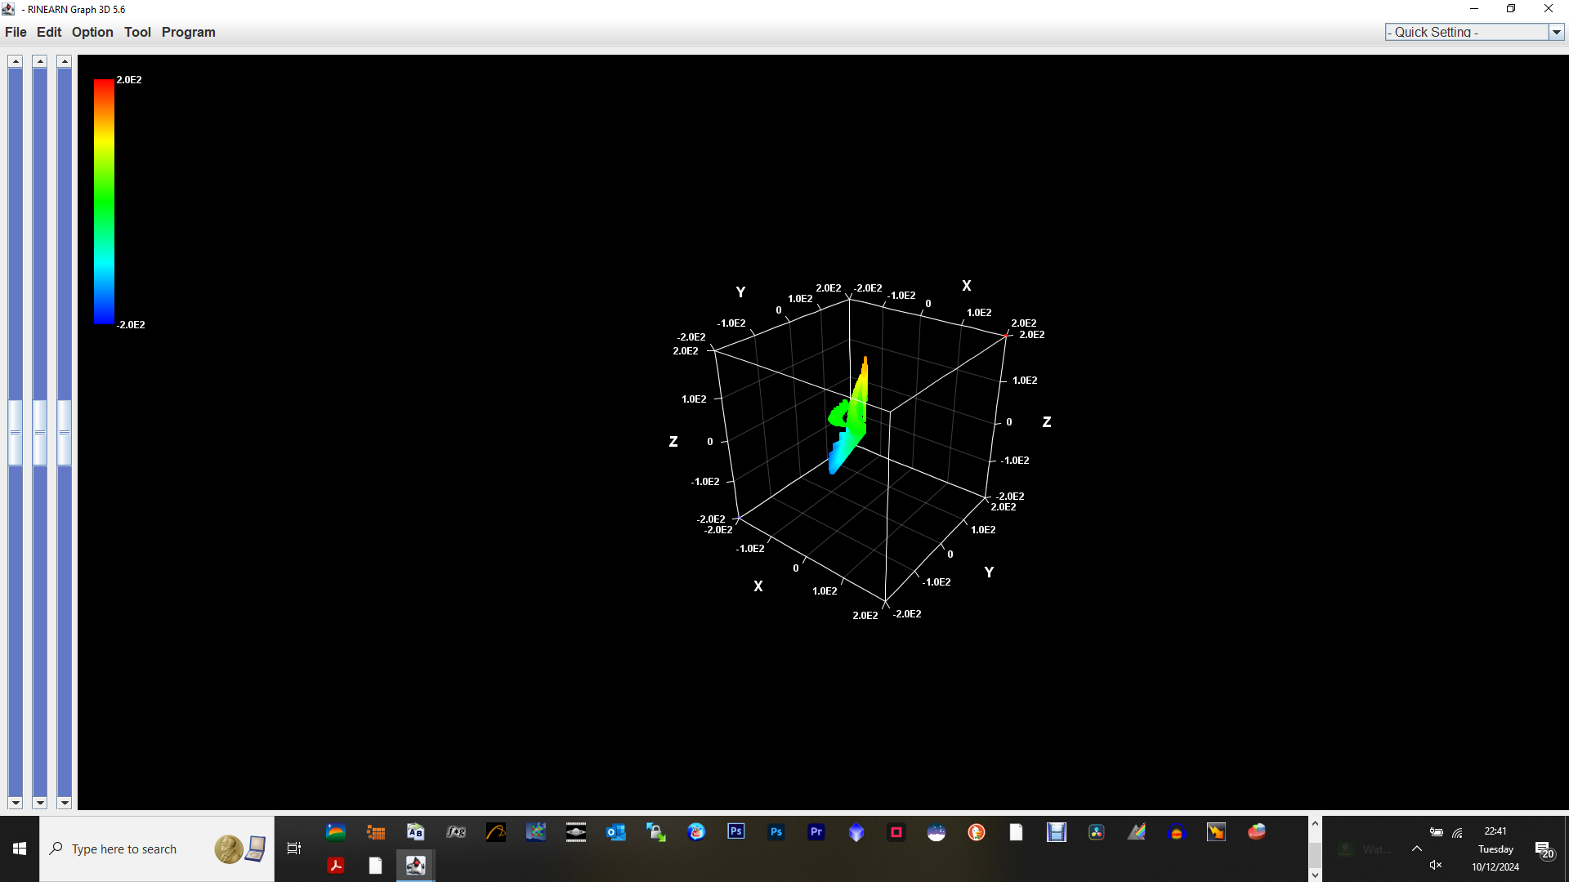
Click <option> in top line:

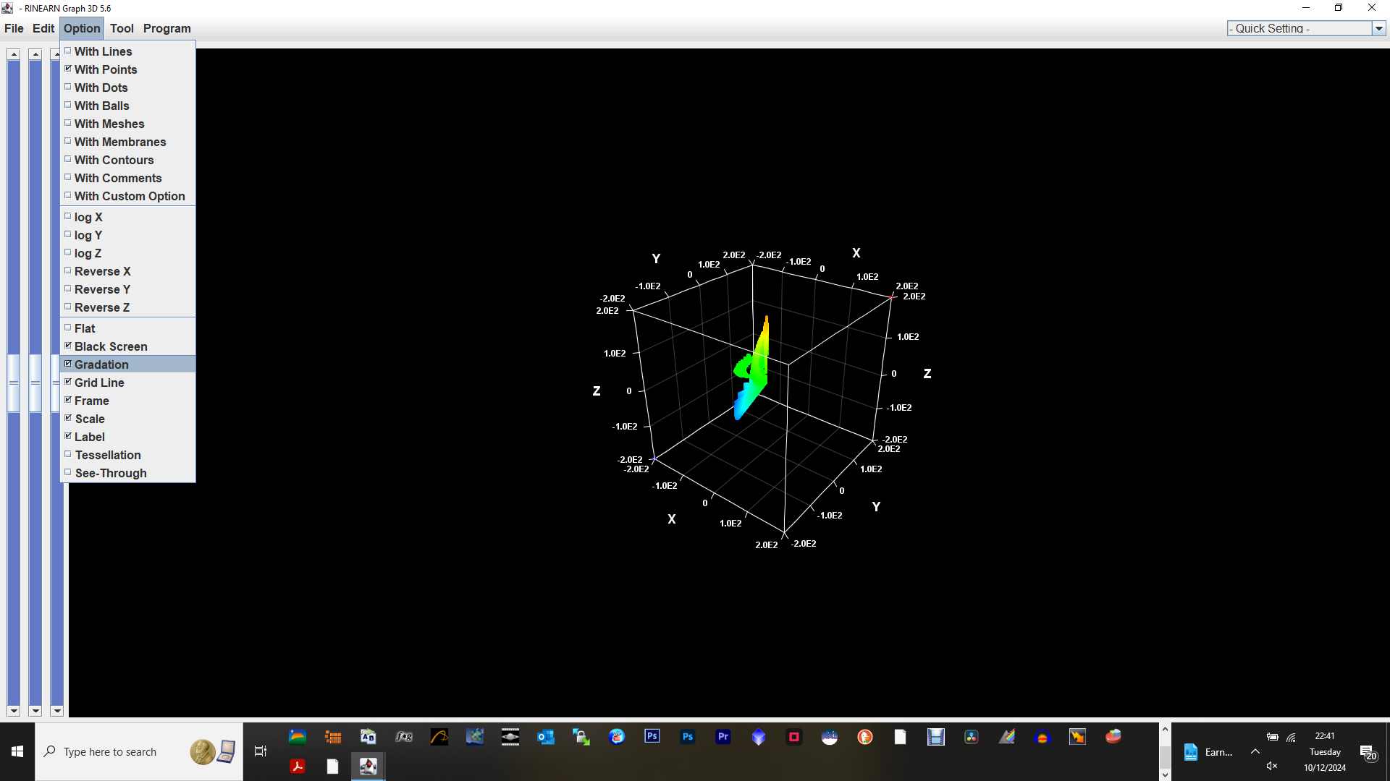
If <gradation> is selected then unselect it.
Now select <gradation> (so you may have unselected it then selected it again!)
This brings up this box:
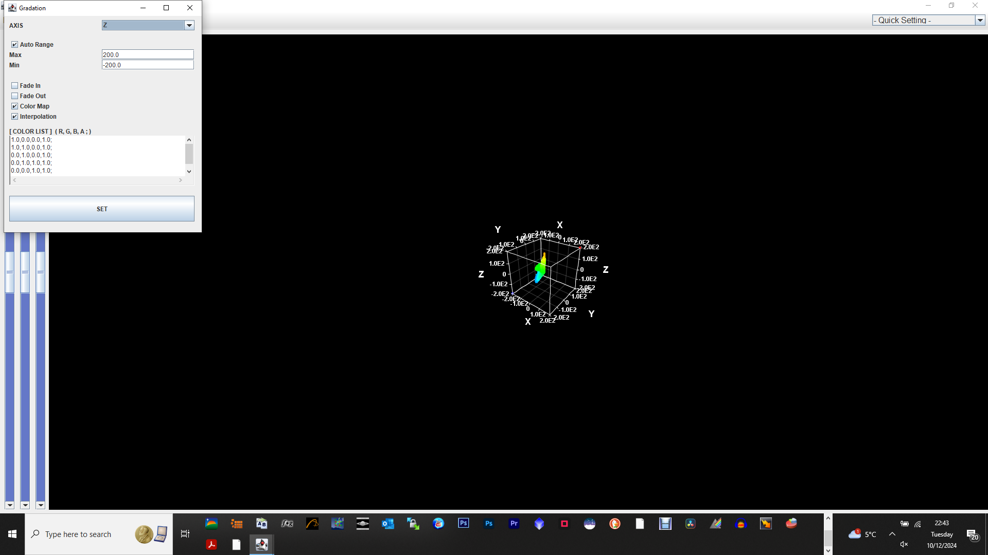
Change <Z> to <column 4>
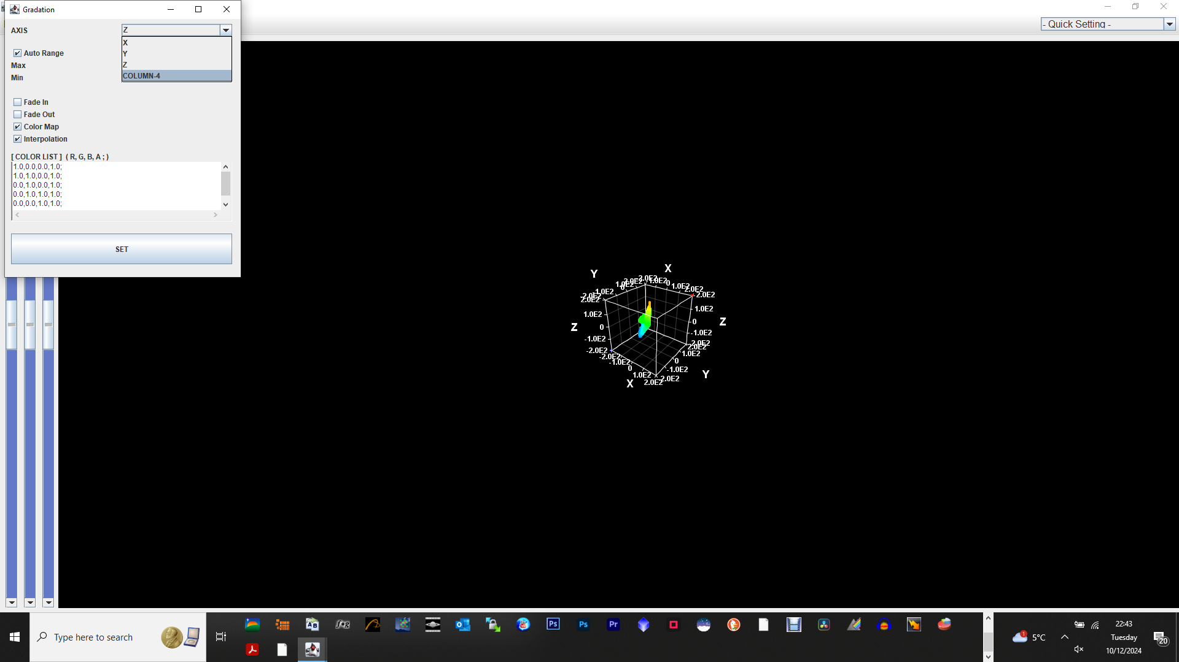
Tick <fade in>
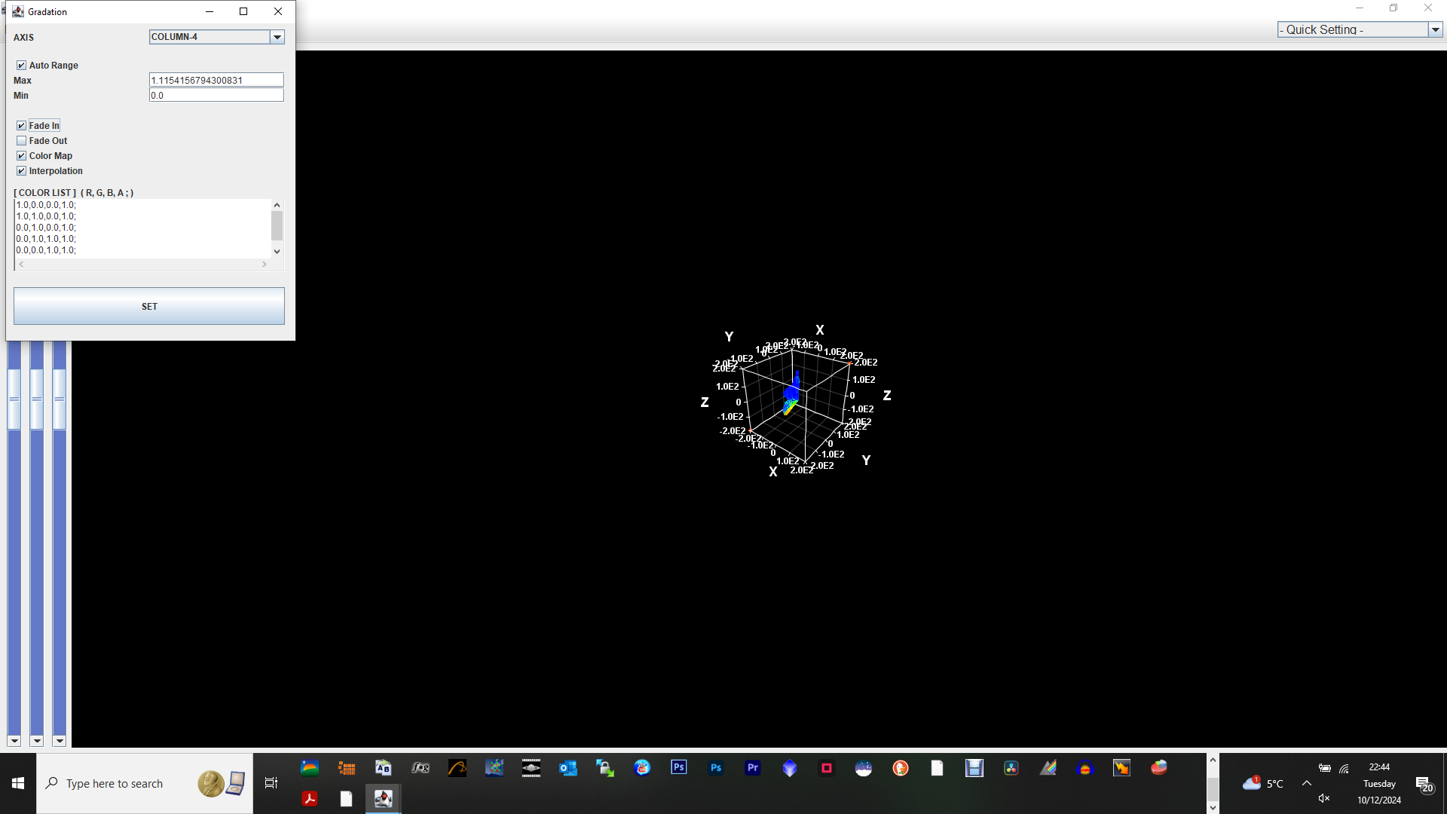
Increase sliders to maximum:
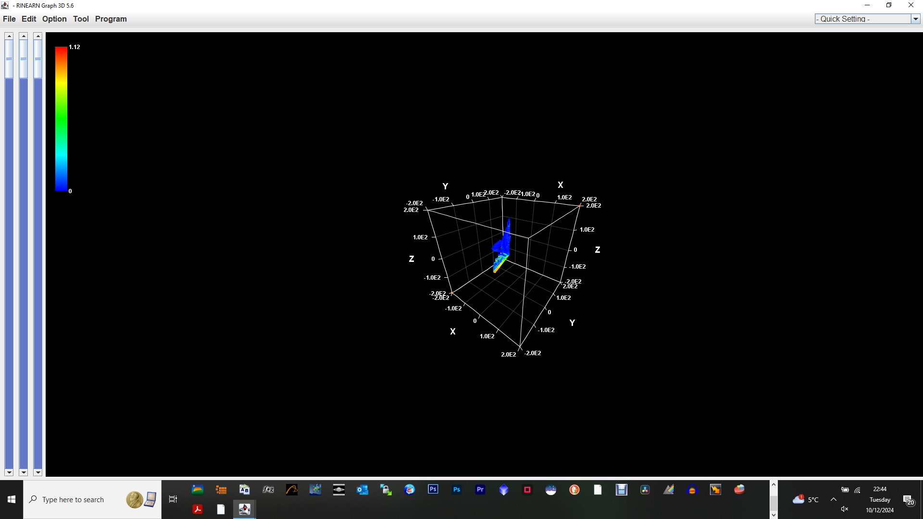
Now select <edit> - <set camera>
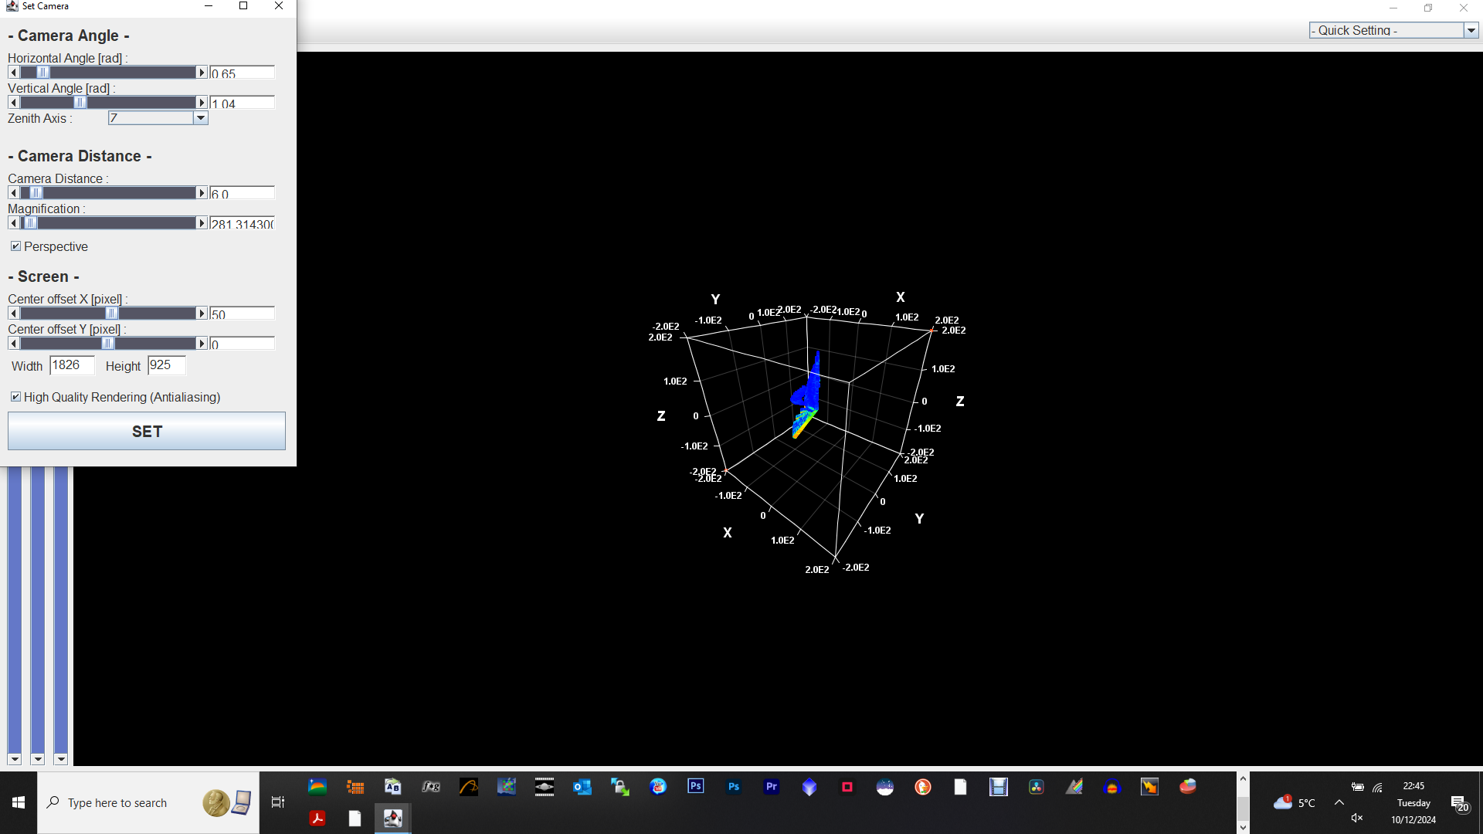
Settings such as magnification and camera distance can make a big difference:
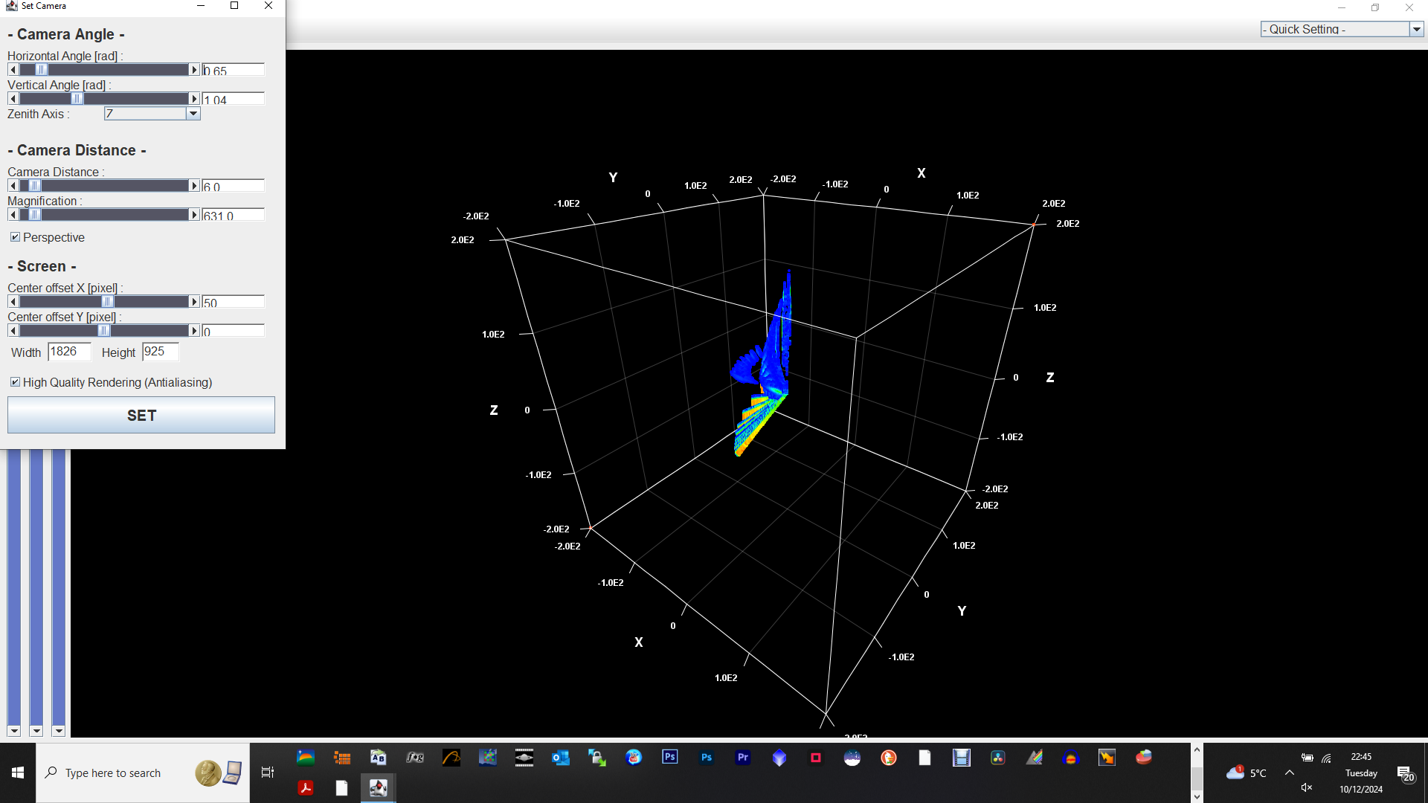
Select <edit> - <set range> to get rid of blank space on 3D plot and increase size of data plot:
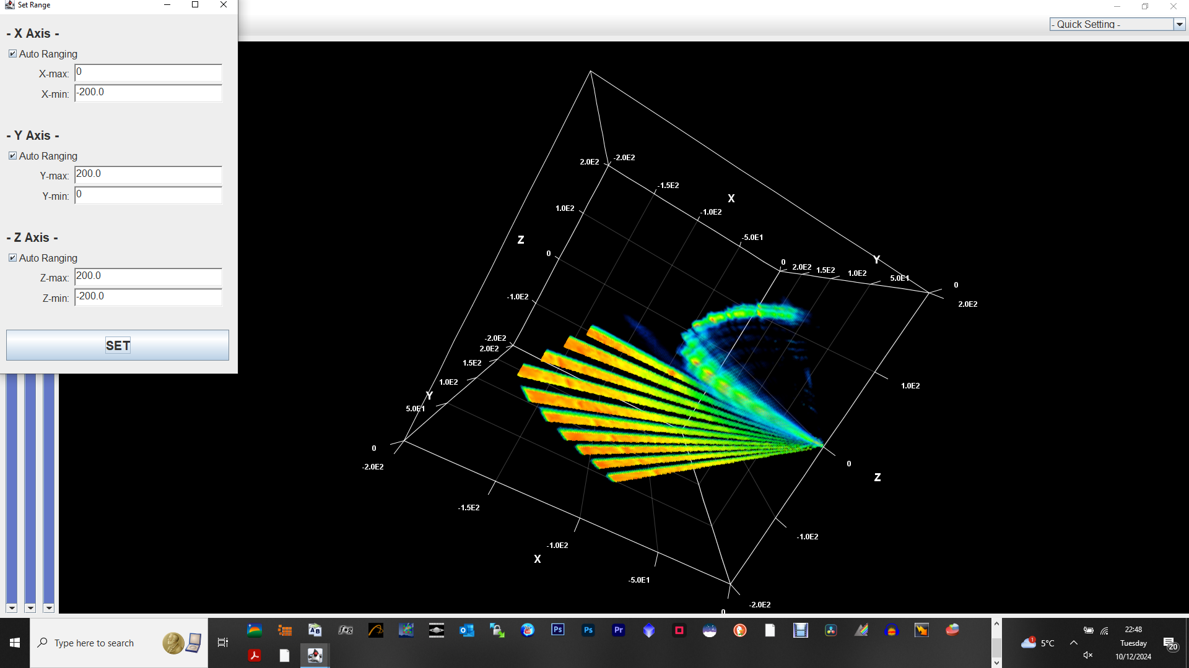
Following is excellent settings for LRO Ptarmigan data:
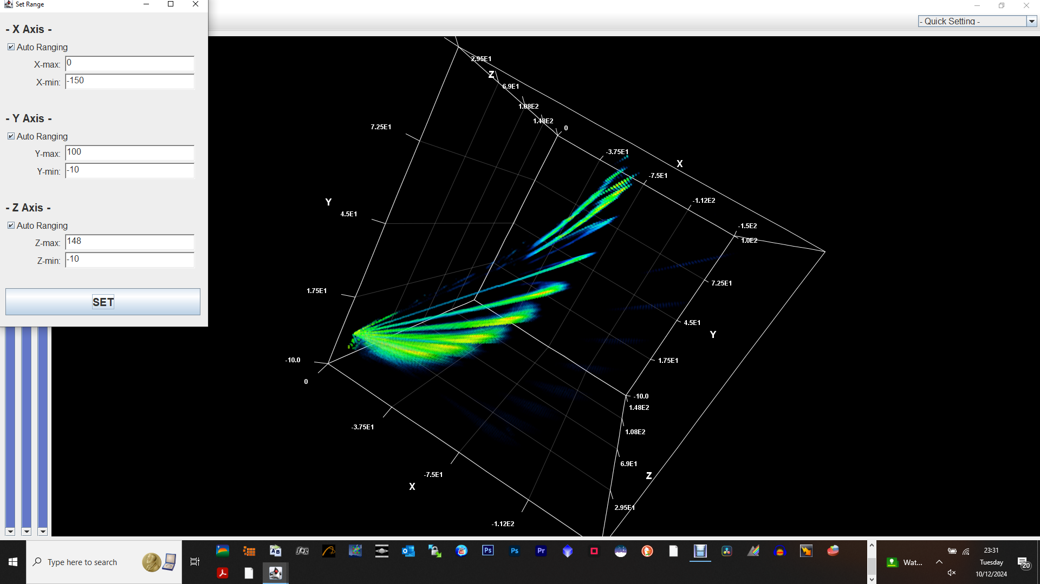
Click on the graph somewhere and drag to change perspective. I then screenshot the image (alternatively it can be saved directly from Rinearn3D) and then pasted it into Adobe Photoshop, cropped it and changed levels to bring out features – in images below, I used this technique to make the 2nd galactic arm (blue) more visible. In Rinearn3D, there is an option to remove the grid and labels from the plot if preferred.
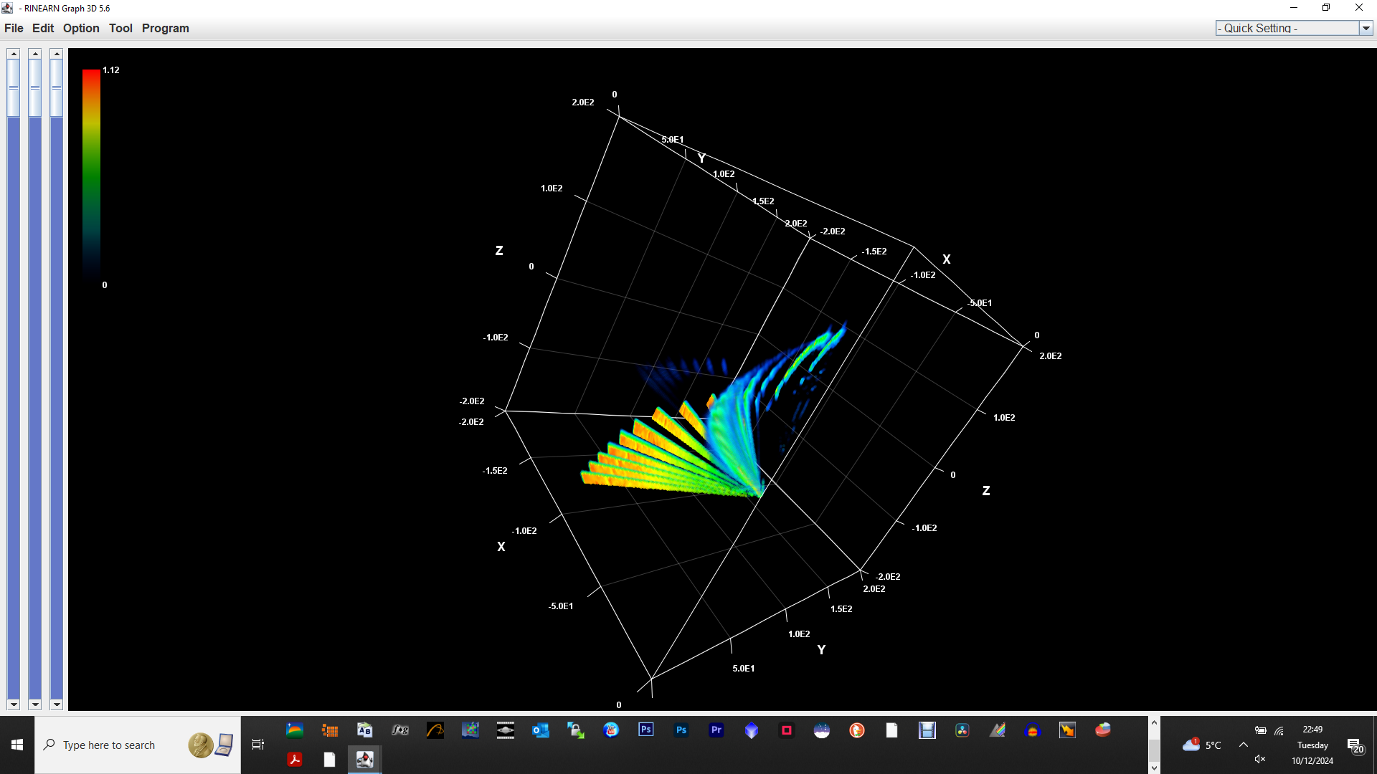
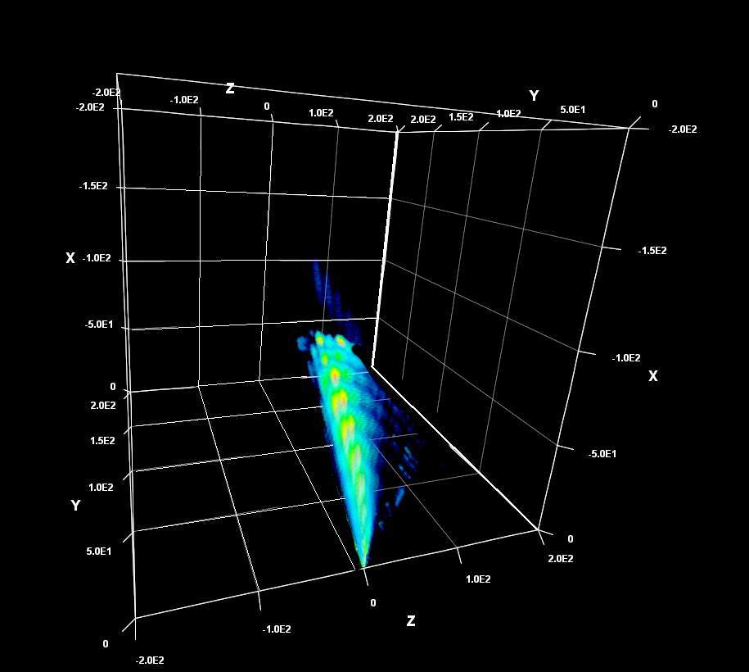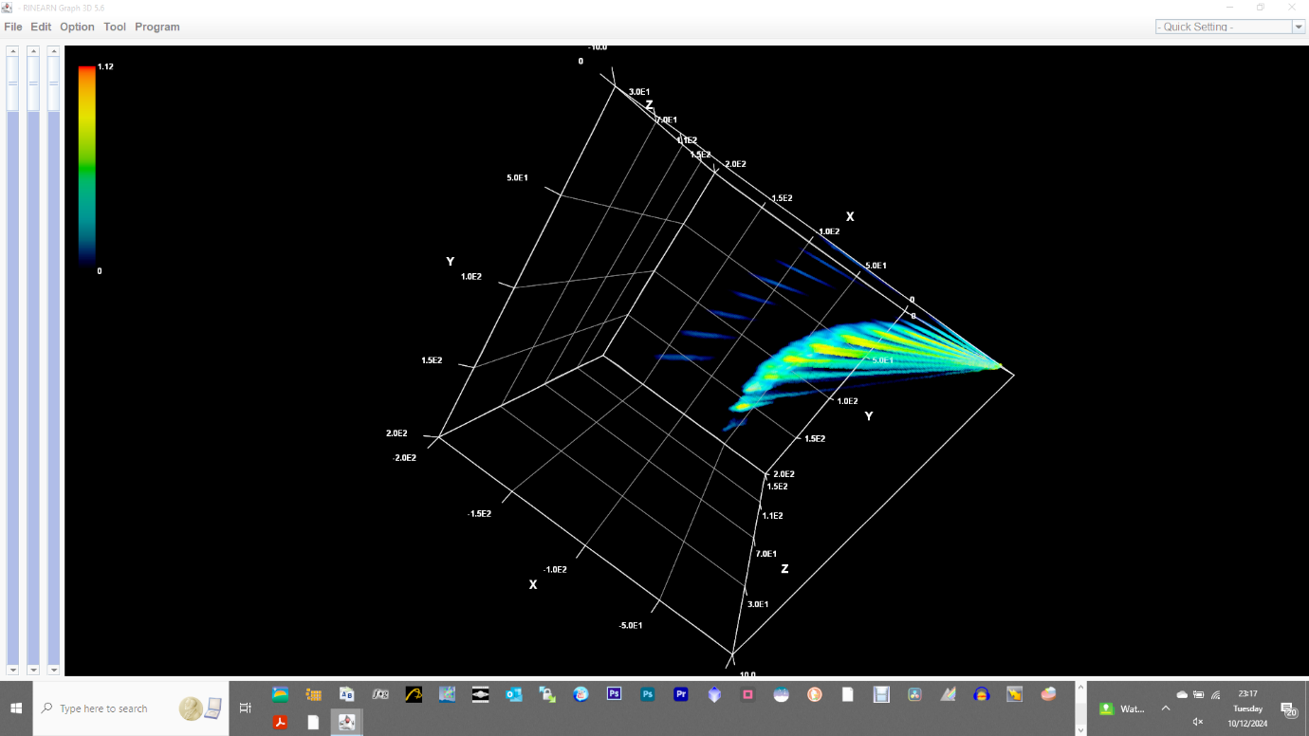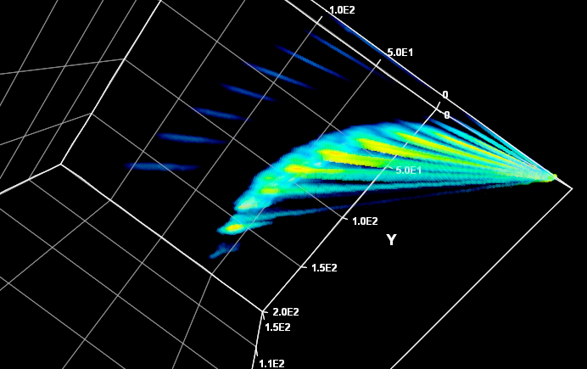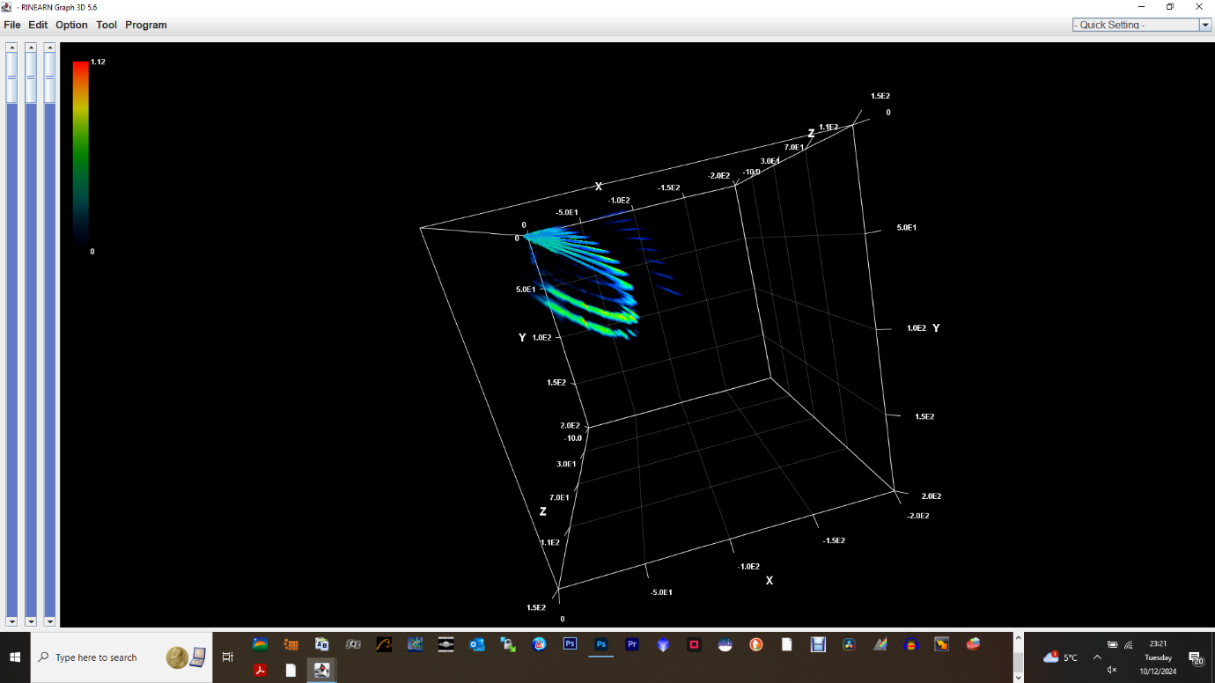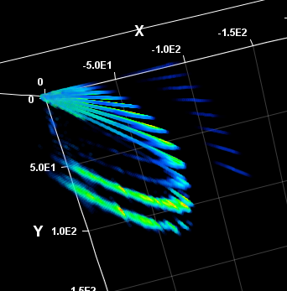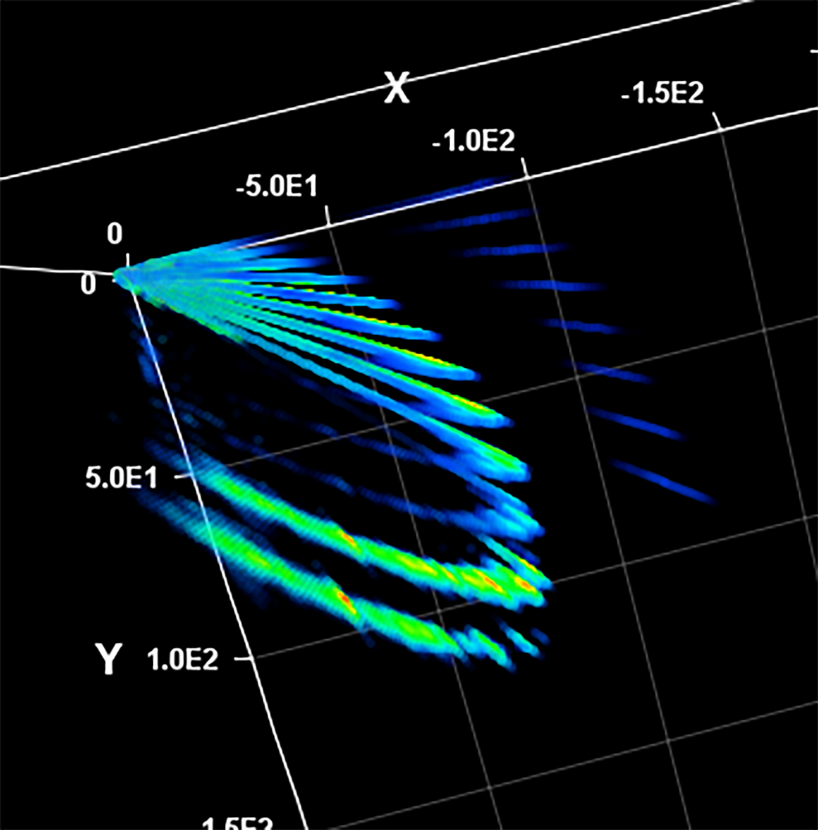
The data encompassed in the purple oval above represents RFI at high declinations – ideally, we would remove these – this can be done with further manipulation of range settings in Rinearn3D.
Examples of further manipulation I have been able to do in Rinearn3D – I have found that changing the range in X, Y, and Z axes ranges enabled me to remove outlying data.
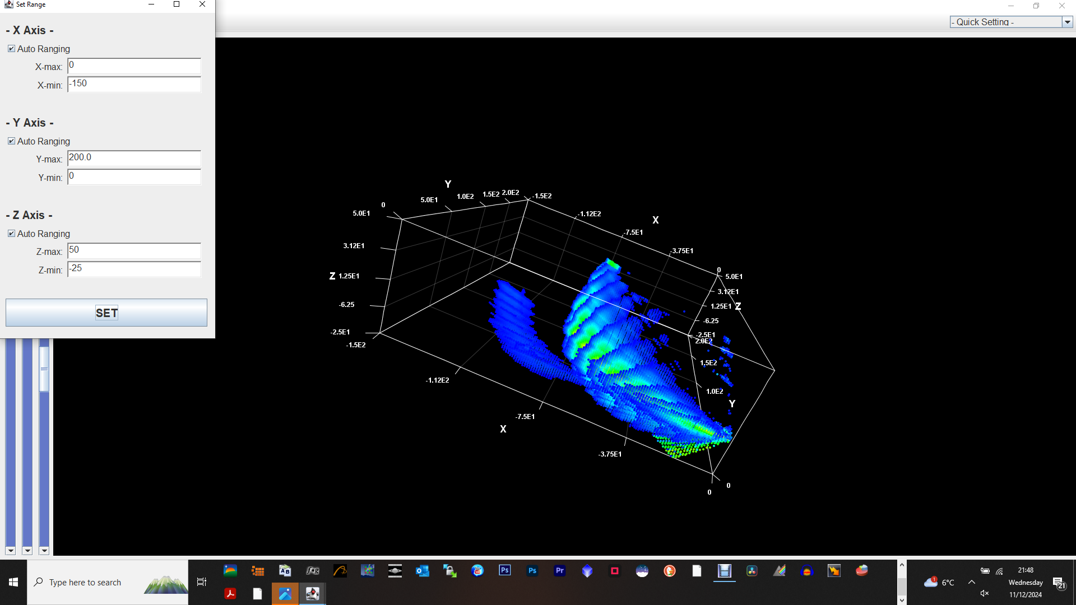
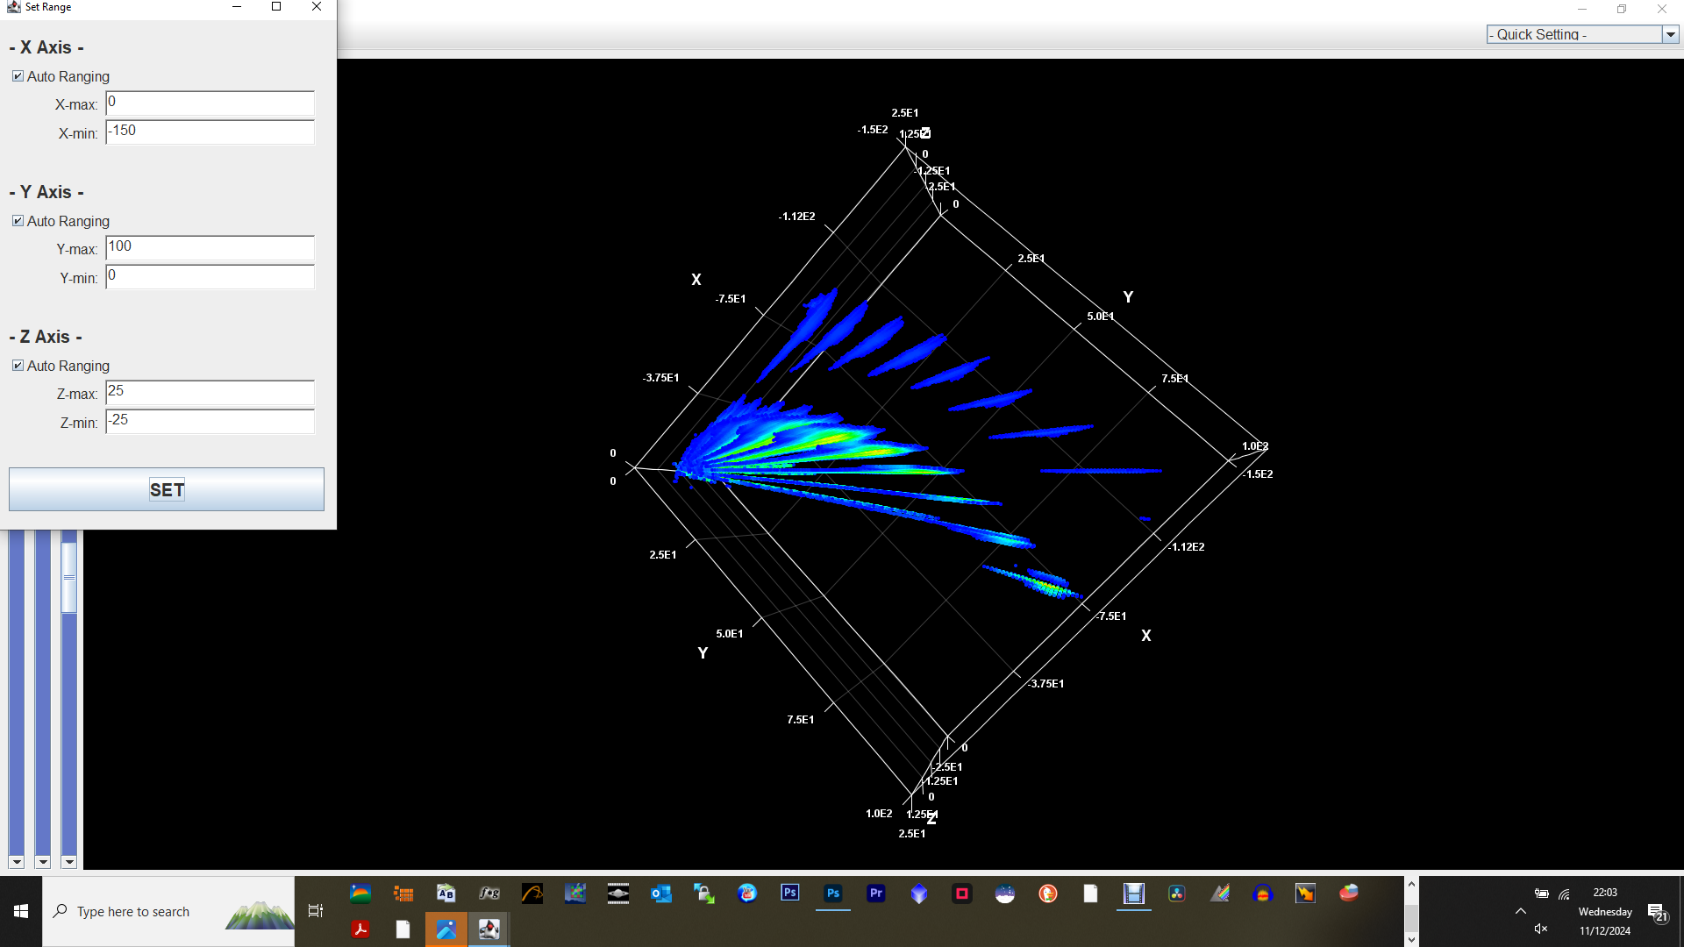
Using sliders on left side can be used to make the images more sensible:

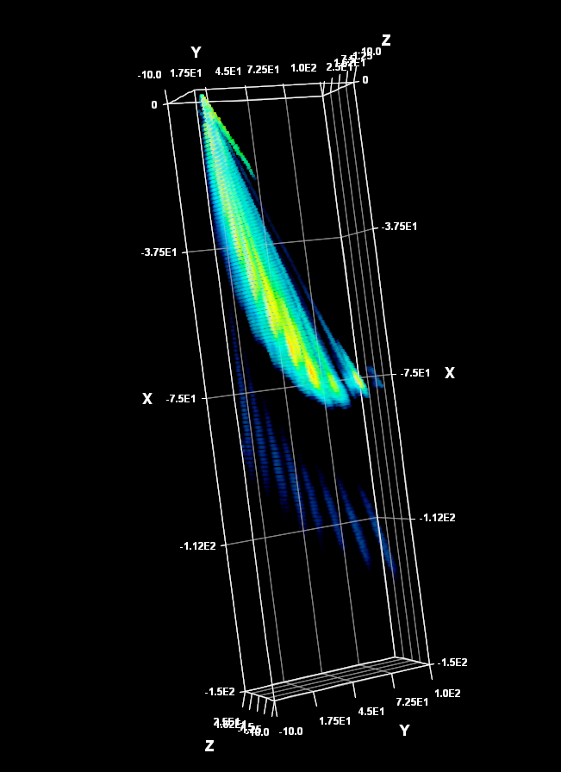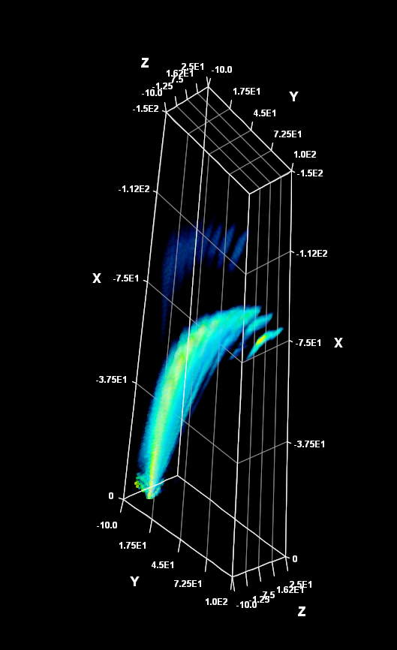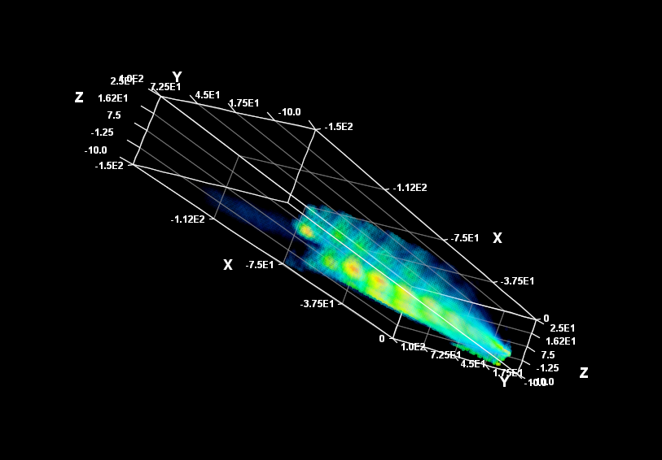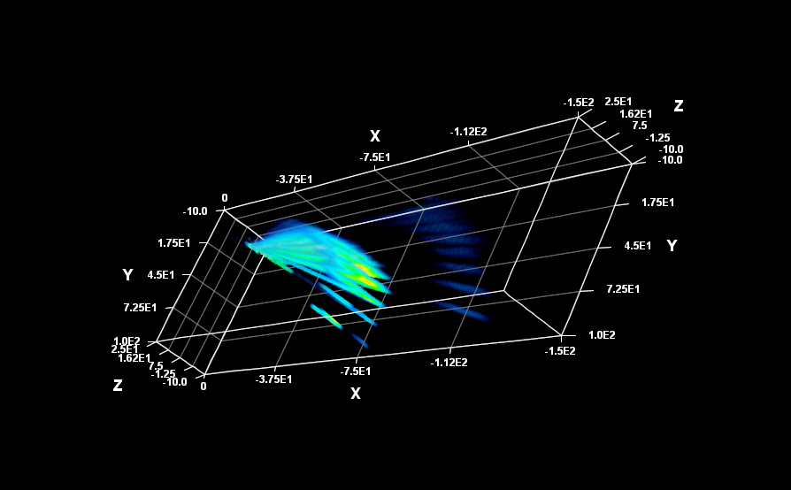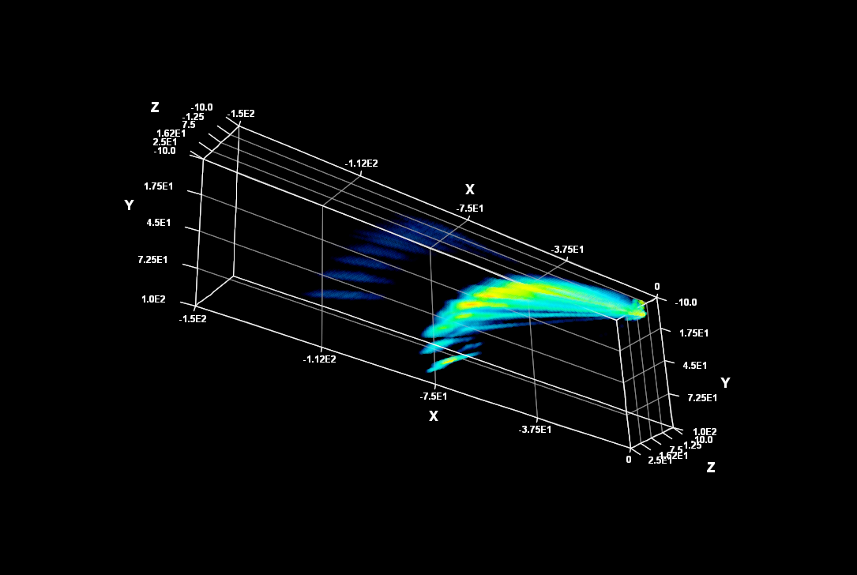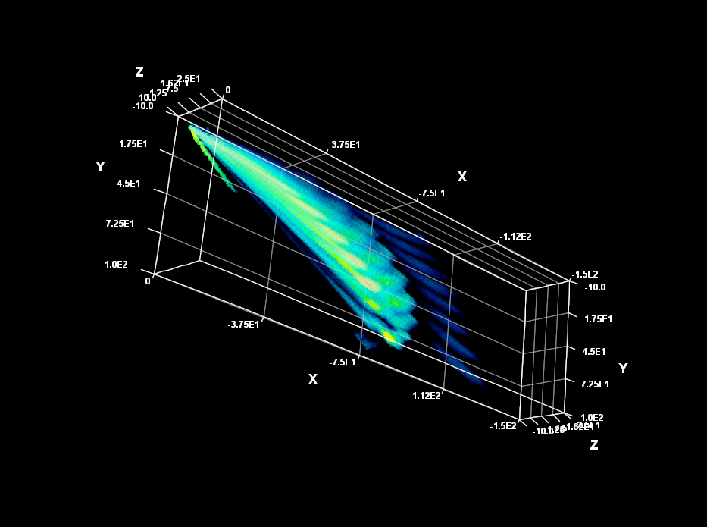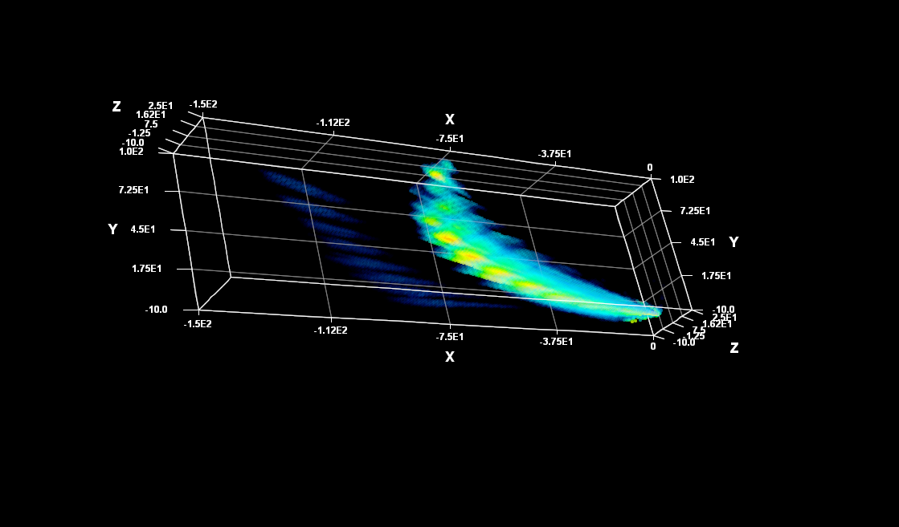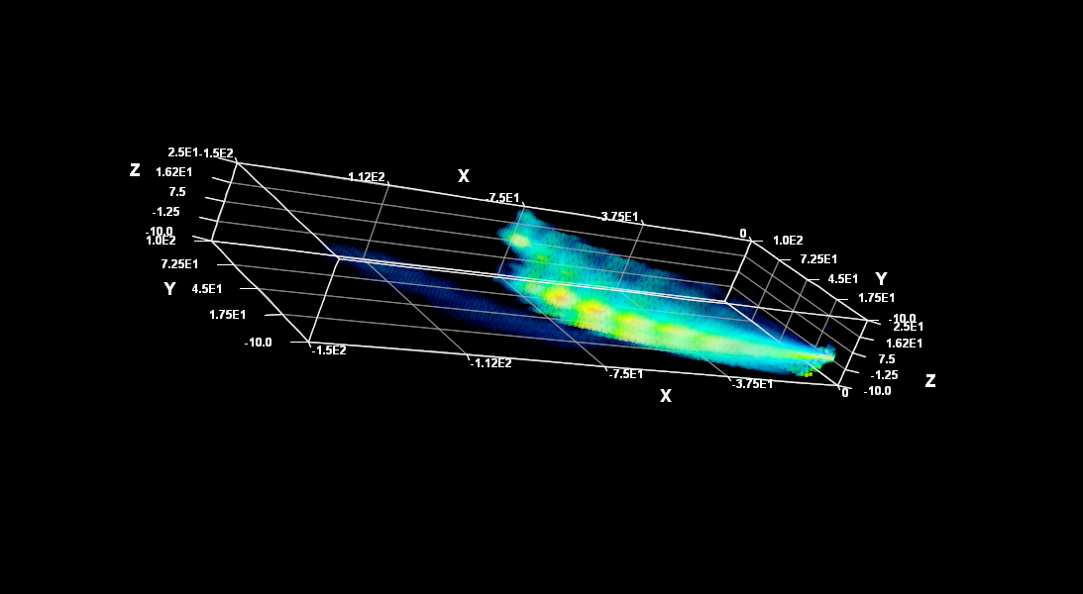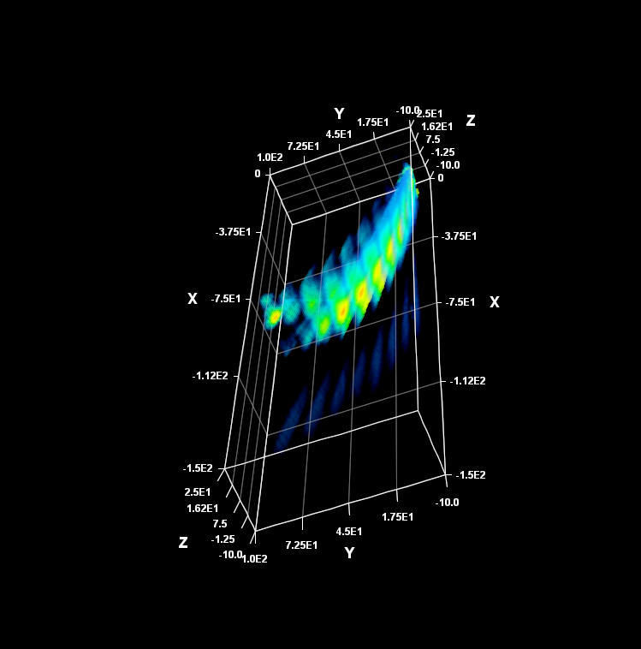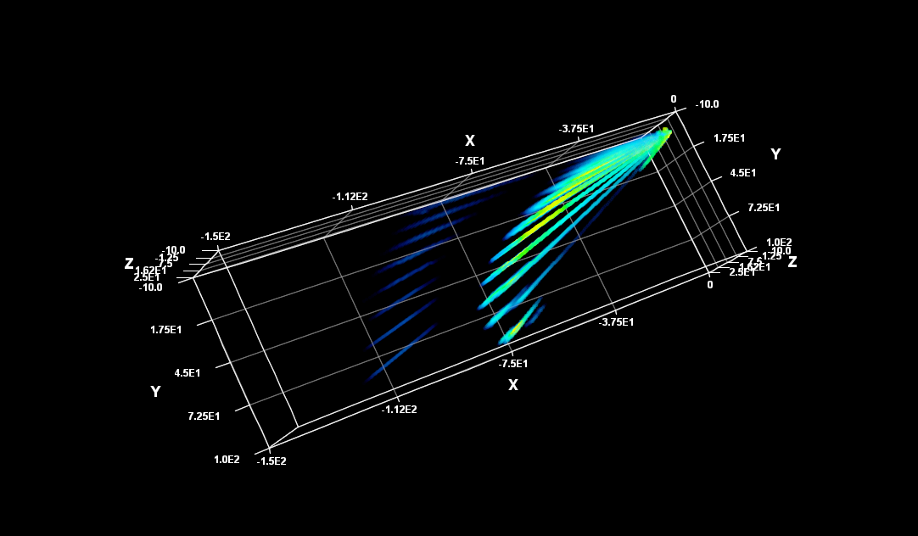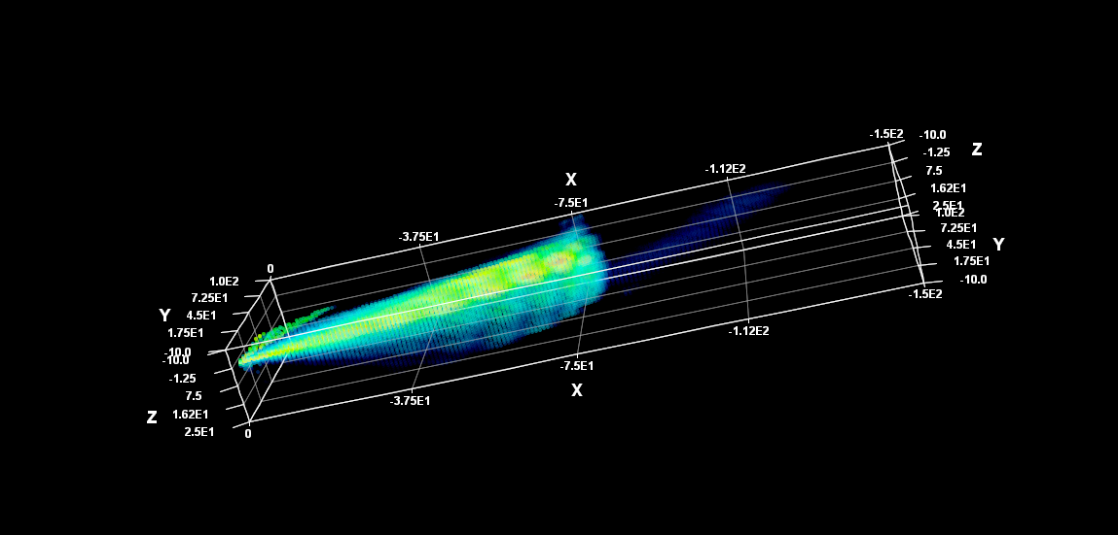
Further changes in the range of X, Y, Z, and the sliders enabled me to improve on the plots I was able to obtain in Rinearn3D, so that I obtained the following:
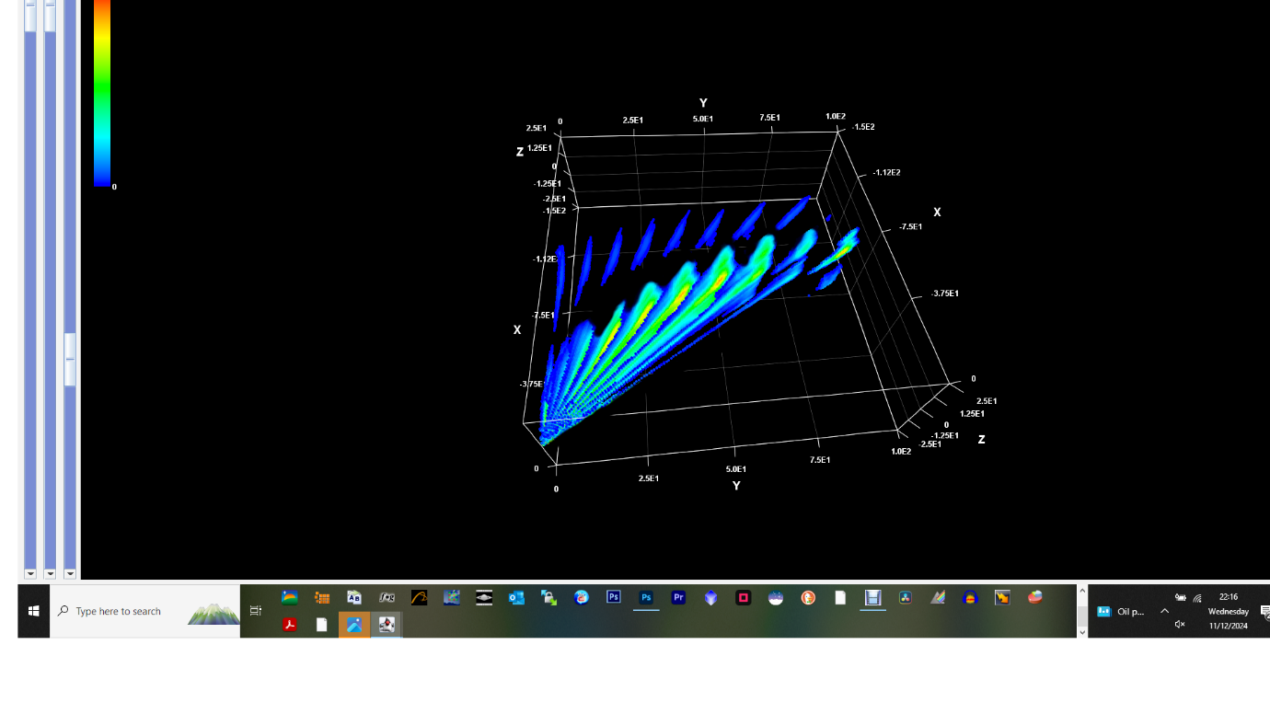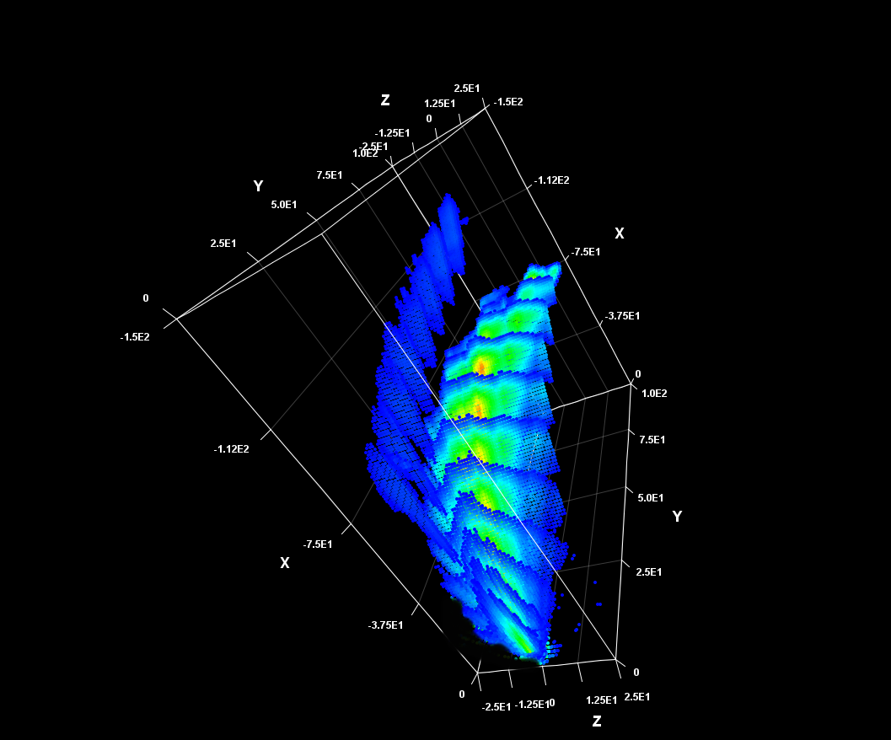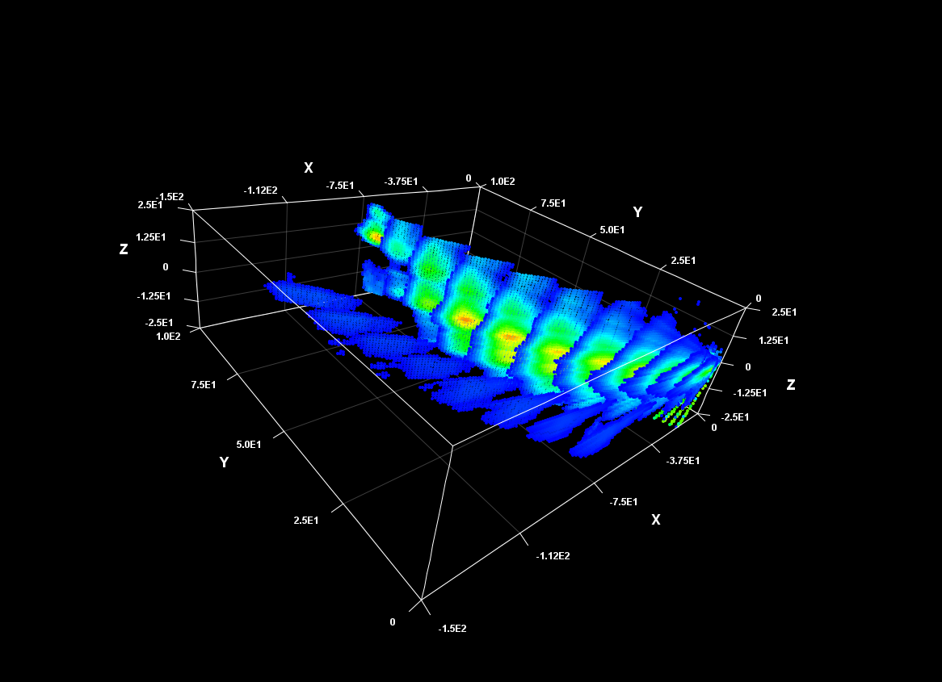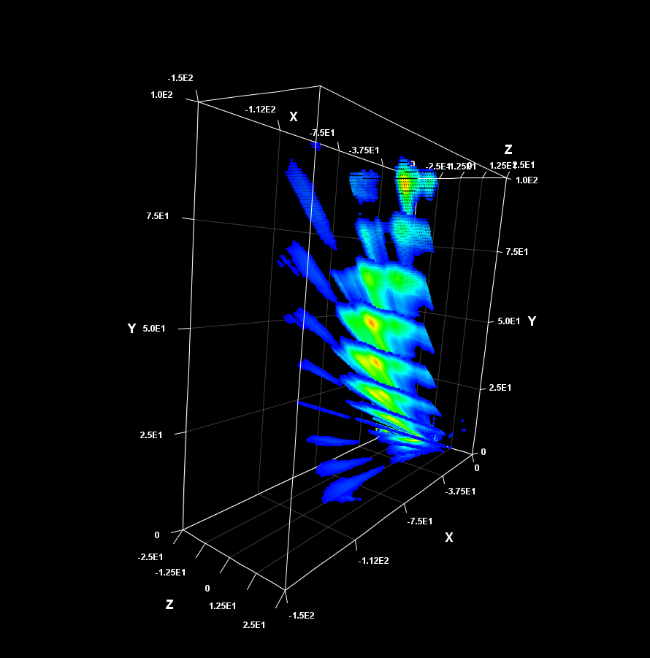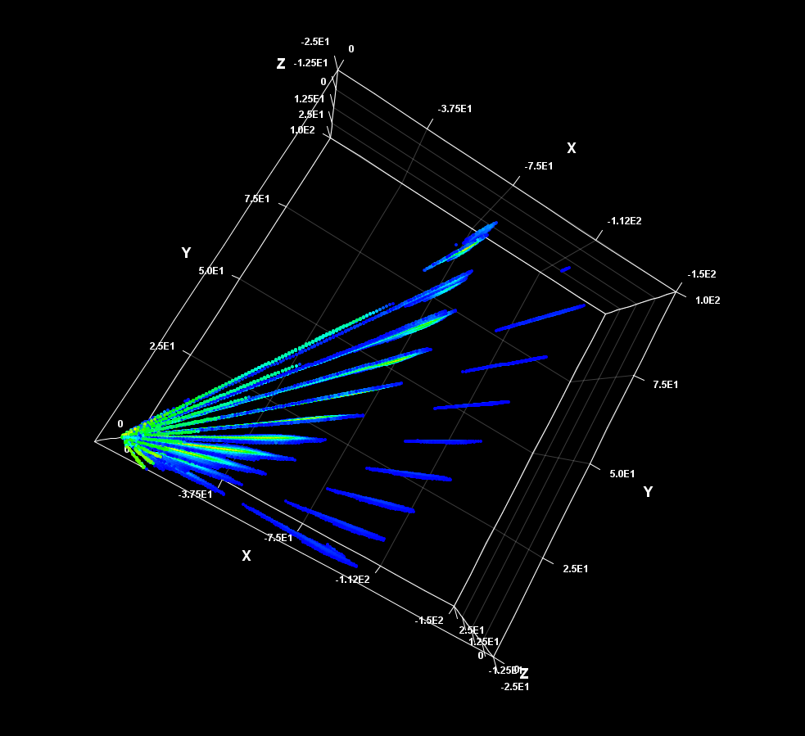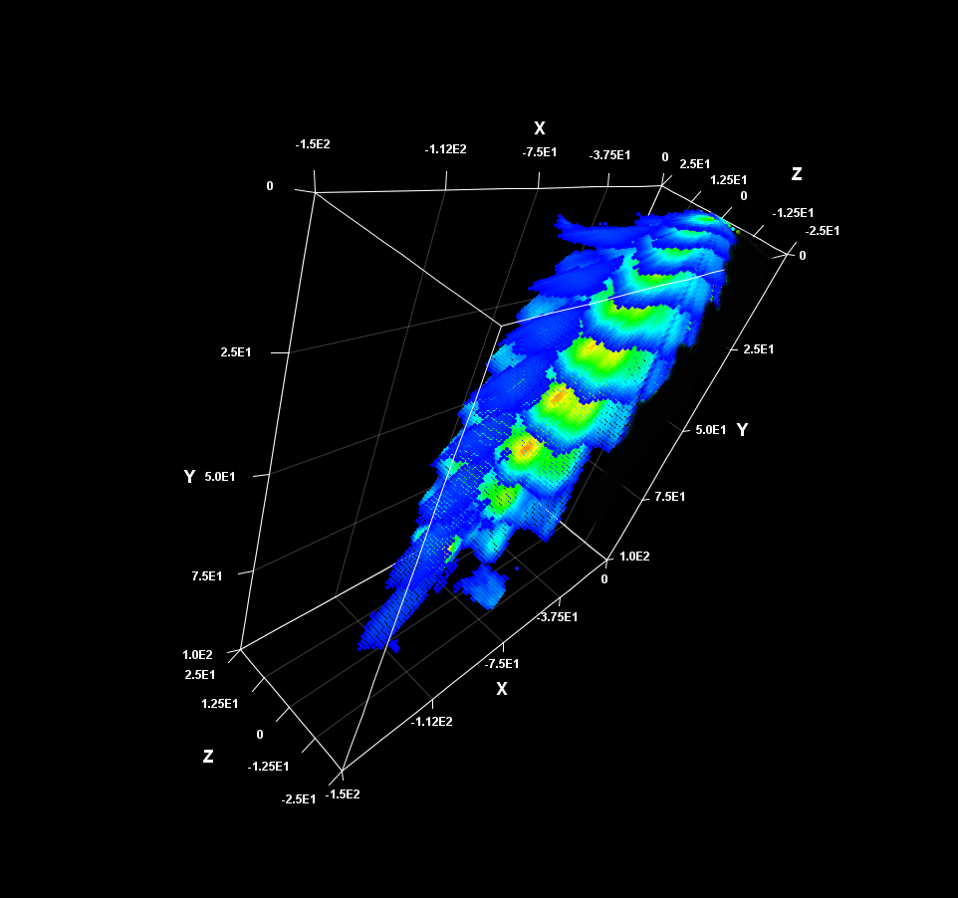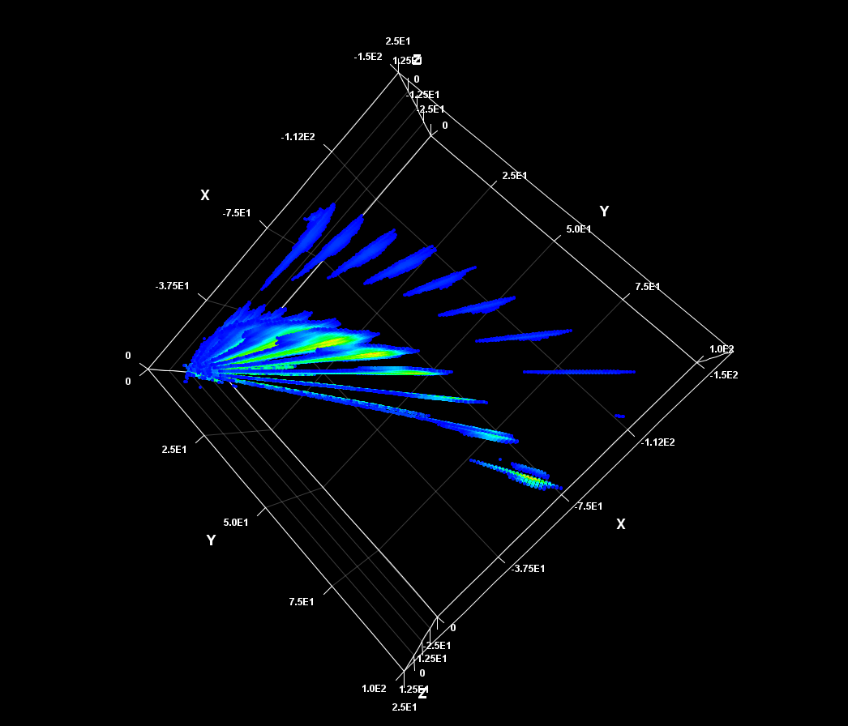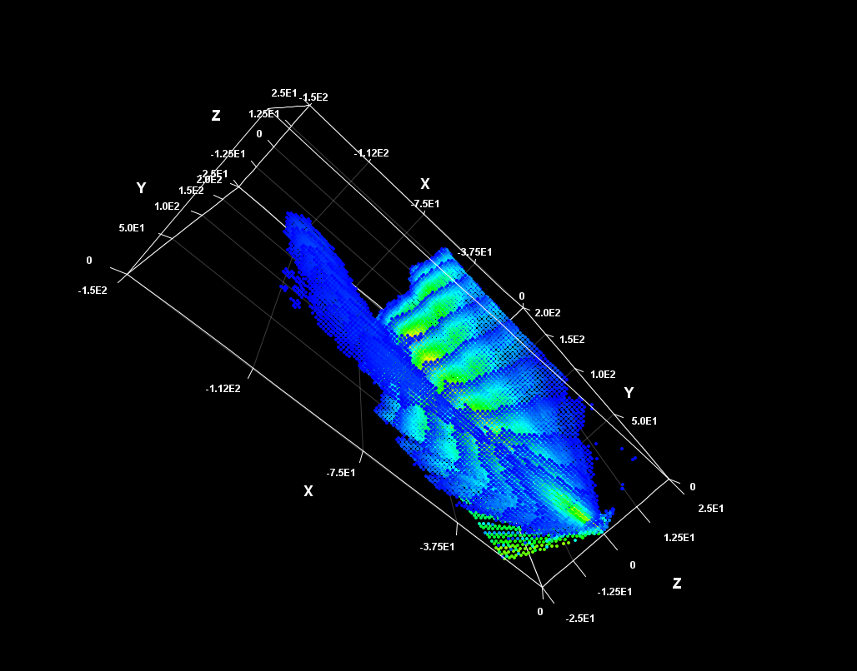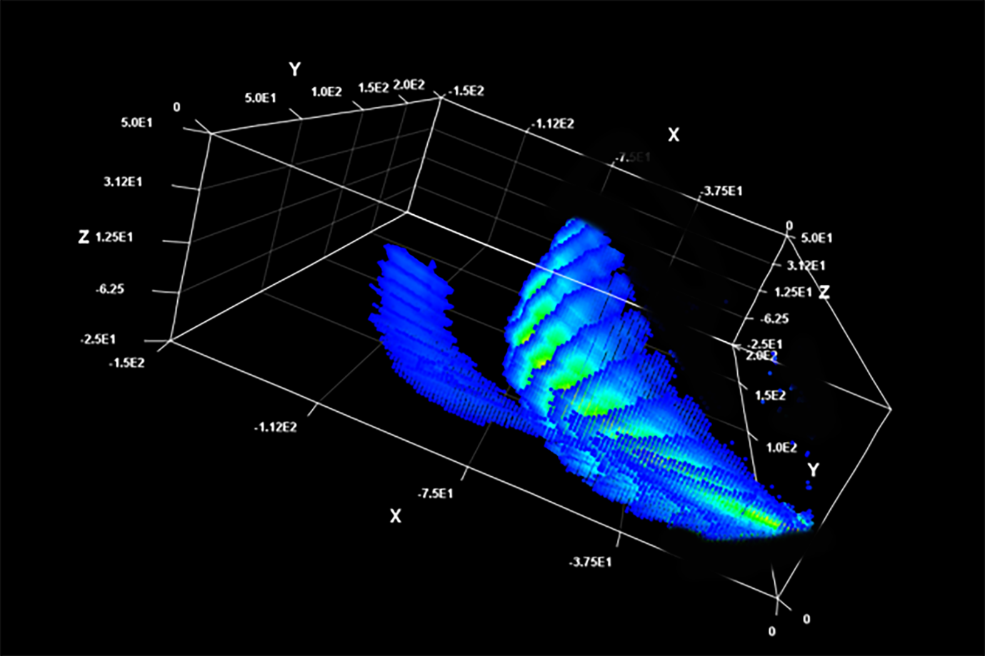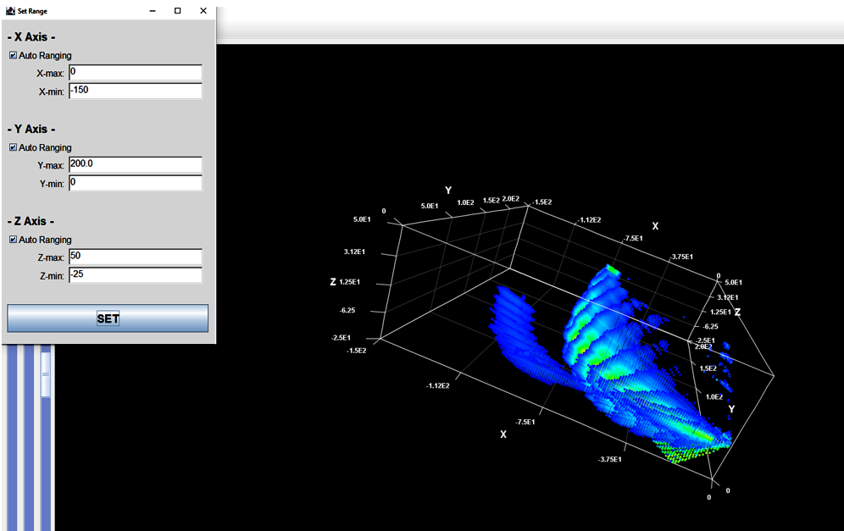
In Photoshop, I was able to lasso select the blue ovals of the 2nd spiral arm (which were relatively faint) and then use levels to move the central slider on levels to improve the brightness of these ovals and make them more obvious.
Animations. To create these directly in Rinearn3D requires using its in-built scripting environment. Ted Cline has written a batch file to record sequential images to build an animation.
I used an alternative method - NCH Debut Video Capture Software (other software options exist that do the same function) – to record an MP4 video of the screen whilst I moved the 3D graphic in Rinearn3D around. This is much easier than the complex options above!
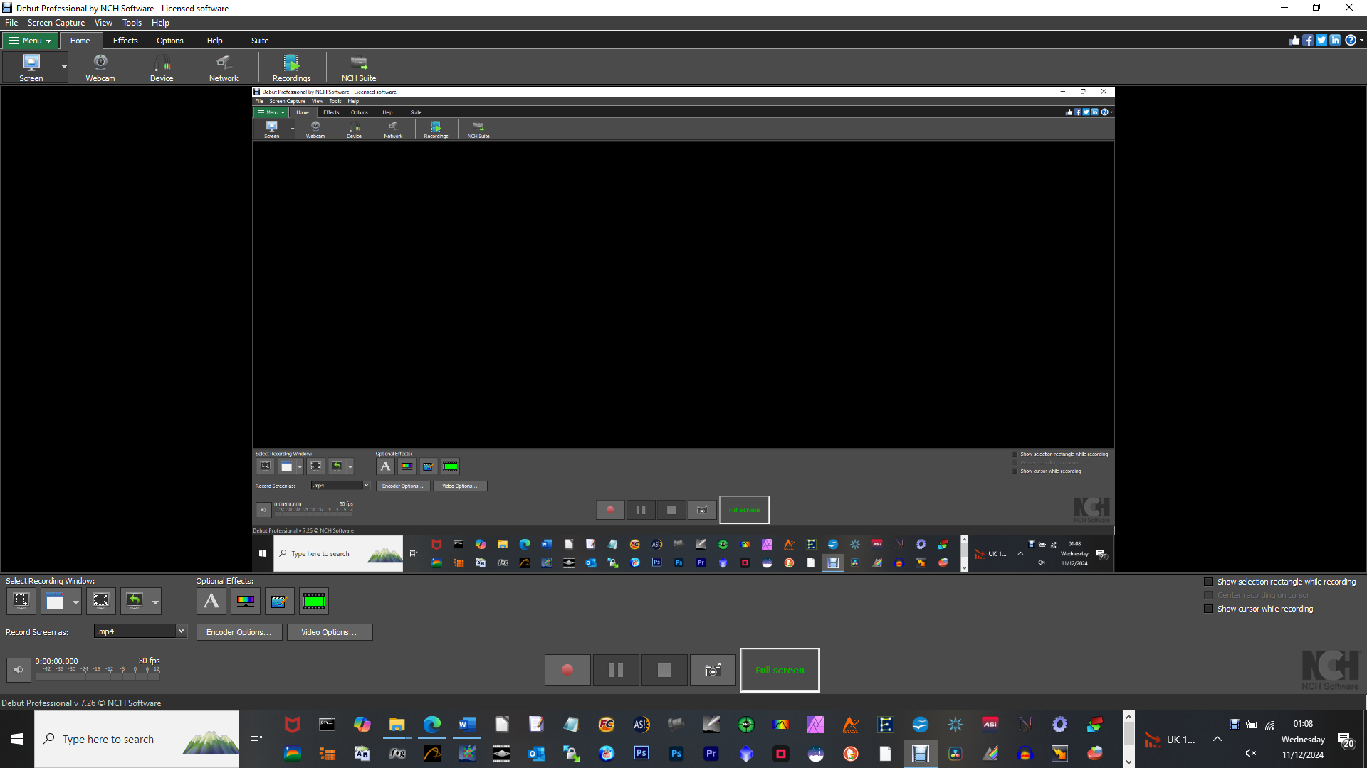
I then used NCH Videopad to trim the front and end of the video and to crop the video to remove the margin in Rinearn3D so that the animation only shows in the video.

